Changelog - V2.3
- Removed some references to specific customer values (like “spx-web-migdal.s3.amazonaws.com”)
- When creating S3 bucket for CloudFront, change url from spx-web-{customer}.s3.amazonaws.com to spx-web-{customer}.s3.eu-central-1.amazonaws.com
- Remove the entire two sections of IAM configuration, as well as Idenitity Provied. Instead, we’re using the same Identity Authorizer (and subsequently the same RBAC roles) for as prod.

IMPORTANT NOTES - watch out for these pitfalls
- {customer} = the name of the customer (varonis, nta, migdal, etc.)
- {env} = “prod-{customer}” or similar (prov-varonis,prod-migdal, etc.)
- Please use the Checkbox buttons to mark completion of steps.
- Make a copy of this document and fill the tables below

Please fill the following table before starting with the Tenant provisioning process:

Variable | Data | Notes
{customer} | plarium
{env} | prod-plarium

Please use the following table wherever the manual notes to copy and store data:
(Come back to the following table when you need to use the data)

Content name | Data | Reference | Notes
App client id | b43qloq0lfugh8btb8c94nf05
Pool ID | eu-central-1_rs6vEDwTX
Pool ARN | arn:aws:cognito-idp:eu-central-1:075493908512:userpool/eu-central-1_rs6vEDwTX
Domain prefix | plarium
Identity pool ID
Distribution domain name | d3ewejntnn5g05.cloudfront.net |  | arn:aws:cloudfront::075493908512:distribution/E2X5S4GJ5OM5MW  E2X5S4GJ5OM5MW
Flagsmith SDK Key | eWfNF4iihKSU6XCPUtsQod
WOPI Port | 3018 | prod-plarium: wopi.spx.com:3018
API Gateway domain name | d2ft7xc2z5icld.cloudfront.net
prod-plarium-external-apikey | JVk8yMjwv55rOVh0QuThA4UKtdb1Orcq4OA8Ftoz
prod-plarium-b2b-internal-apikey | 9BJQJRq7PR9gcQRmFOdKl5DDad3Klf6I4kj0QVnC
google-drive-service-account  Client ID  Email  google-drive-service-account@gdrive-sa-plarium.iam.gserviceaccount.com | 113156680575208422904

Intro
This manual will walk you through creating a full SpecterX customer tenant, including all it’s cloud infrastructure and dependencies.

When going through this manual, pay close attention to the configuration details.

Steps for setting up a tenant:
- Set up AWS infrastructure.
- Define other core-cloud services (Courier, Flagsmith, Twilio, etc).
- Test sending a single file with the default security policy.
- Define integrated cloud service (Google Drive, SharePoint, MCAS, etc).

When creating the AWS resources, leave the configuration values and definitions as “UNDEFINED” (write this UNDEFINED string instead of values wherever you don’t have the value yet).

Table of Contents
Intro 2
Table of Contents 2
Required Privileges 5
AWS 5
Azure 5
Google 6
CI (Jenkins) 6
Setting up AWS resources 7
Web Hosting 7
We need to create bucket which will host Specterx web site. 7
S3 bucket 7
CloudFront 11
Route53 DNS record 14
Cognito - Part 1 15
Create new Cognito User Pool 15
Attributes 20
Policies 20
MFA and Verifications 20
Message Customizations 21
Tags 22
Devices 22
App clients 22
Triggers 23
App Integration 23
IAM 24
Create IAM roles for each of the users roles we have in our platform 24
Administrator 24
Collaborator 25
External 25
Viewer 26
Cognito Identity Pool 27
Create new identity pool 27
IAM (again) 29
Trust relationships 29
SaaS Dependencies 31
Courier 31
Flagsmith 31
Codebase 33
Update the common Configuration repository 33
Environments.yml 33
SystemConfig.yml 34
Update specific configuration files in each repository 35
What repos will we update and create a branch for? 36
Library repositories 36
Microservice repositories 36
Web client repository 36
Microservice repositories 36
Jenkinsfile 36
Serverless.yml 37
Python requirements file 38
Web client repository 38
env.ts 38
Jenkinsfile 41
Create new Branches for the tenant 42
Create branches 42
Push all branches to remote 42
Creating a branch from BitBucket GUI should look something like this: 43
Creating a branch from CLI ( git must be installed ): 44
Update Jenkins automated builds 45
Create a tab for the new branch (through Jenkins) 45
API Gateway 49
Register Custom domain name in DNS 49
Connecting AWS resources to each-other 51
Cognito - Part 2 51
Create Groups 51
Set up Triggers in Cognito 53
Integrations 55
Azure Information Protection (AIP) 55
Azure Tenant 55
Setting up a new tenant on the AIP Encryption Server 55
SharePoint Mediation Site (Open with Office 365 feature) 55
Google Mediation Account (Open with Google Drive feature) 55
Google Drive Application (Share from Google Drive feature) 55
Viewer (WOPI and Office Online) 55

Required Privileges
To run many of the operations on this manual you will require elevated privileges in our AWS account, Google Workspace, Azure and MCAS portals, and maybe a few more. This section will help you set these up with one of the other admins on the team.

AWS
You will need privileges to the AWS console.

Azure
You will need privileges to the Azure admin console.
To do that, login to our main Azure tenant (specterx.com) as one of the current Azure admins. Make sure it’s not one of the other tenants.
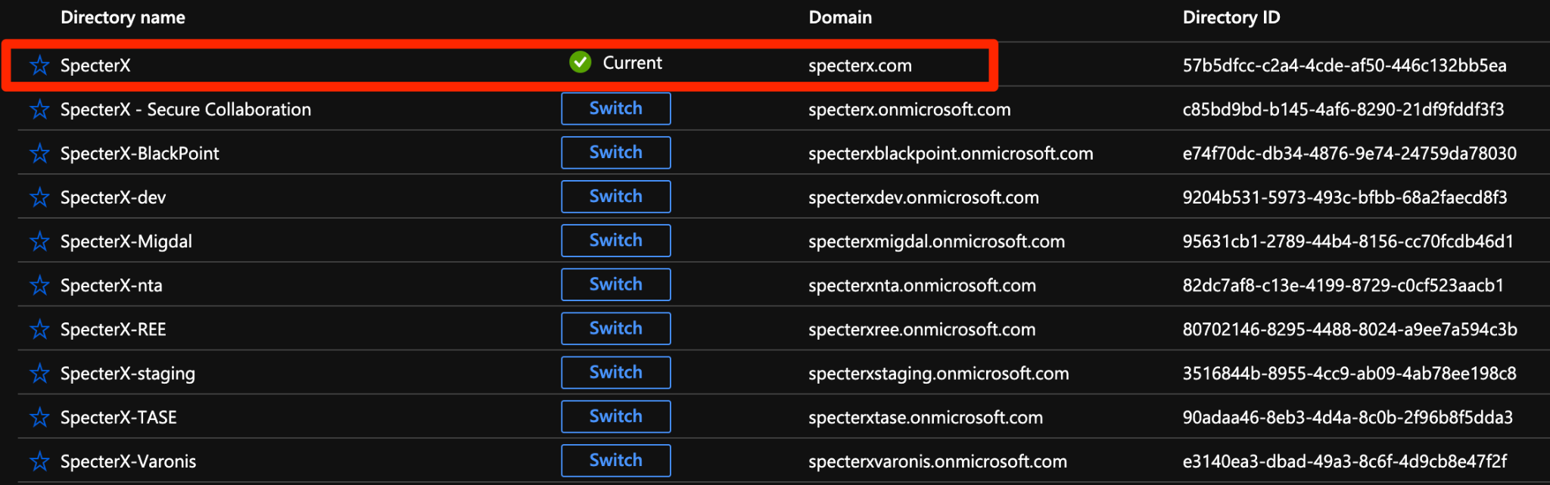
Go to the subscription page: https://portal.azure.com/#blade/Microsoft_Azure_Billing/SubscriptionsBlade

You should see only one subscription named “Pay-As-You-Go”

Click on it and go to “Access control (IAM)”. There you can view current administrators by clicking on “Classic administrators” and add administrators by clicking “Add”.
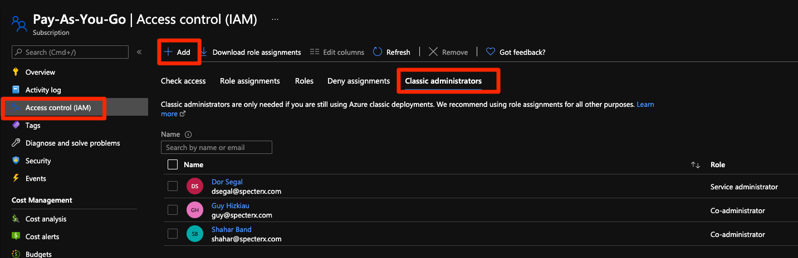

Click Add to add the next admin.

Google
Go to https://console.cloud.google.com/apis/dashboard

Click on the project name on top to open the project's dialog. From that dialog, click on the options button on the right.
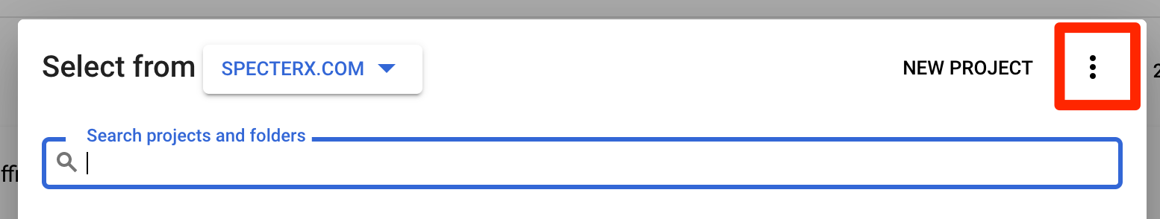

Select “IAM/Permissions” and add the user here.
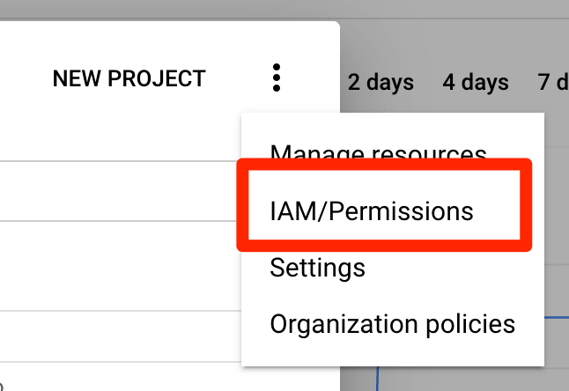

CI (Jenkins)
Ask one of the other administrators to add you to Jenkins so you can run builds

Setting up AWS resources

Web Hosting

We need to create bucket which will host Specterx web site.

S3 bucket
- Create a S3 bucket with this name convention:
spx-web-prod-plarium
E.g. spx-web-prod-{customer}

- Copy settings from existing bucket (usually from the most recent one created)
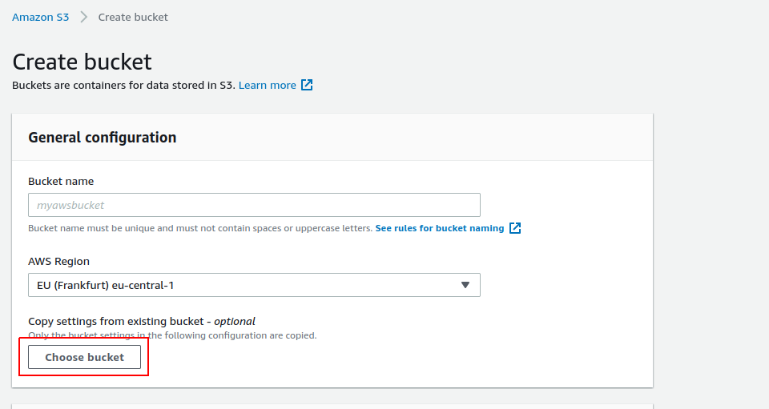
- Make sure static website hosting is enabled (if section is missing, follow instructions below)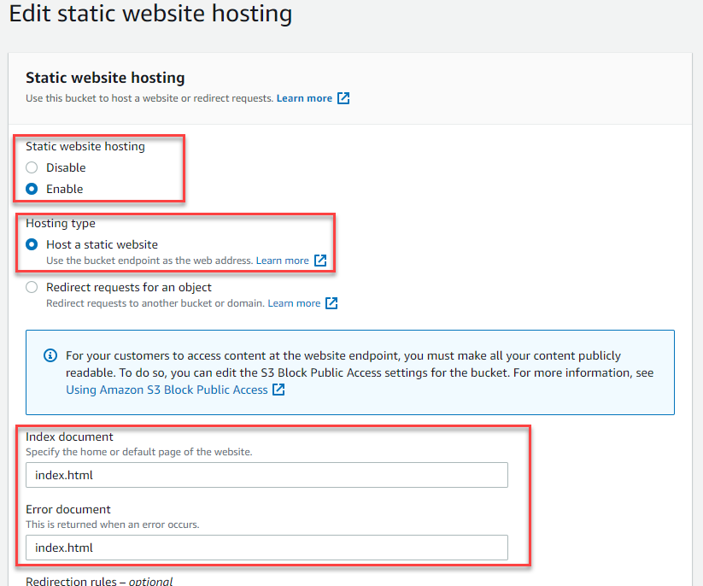

- Make sure “Block Public Access” is unchecked, and acknowledge.
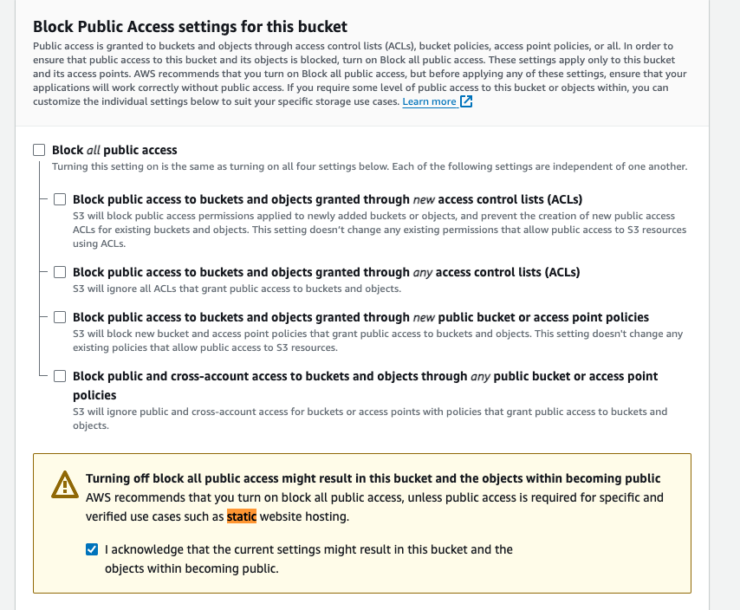
- In case “static website hosting” is missing configure separately from the general properties:
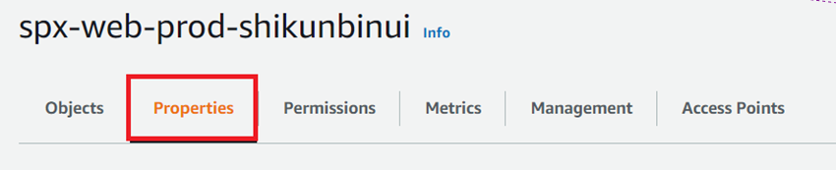
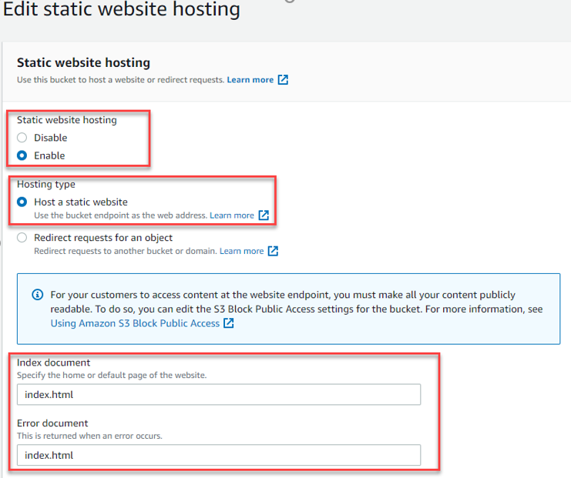

- In Permissions tab enter the following Bucket policy

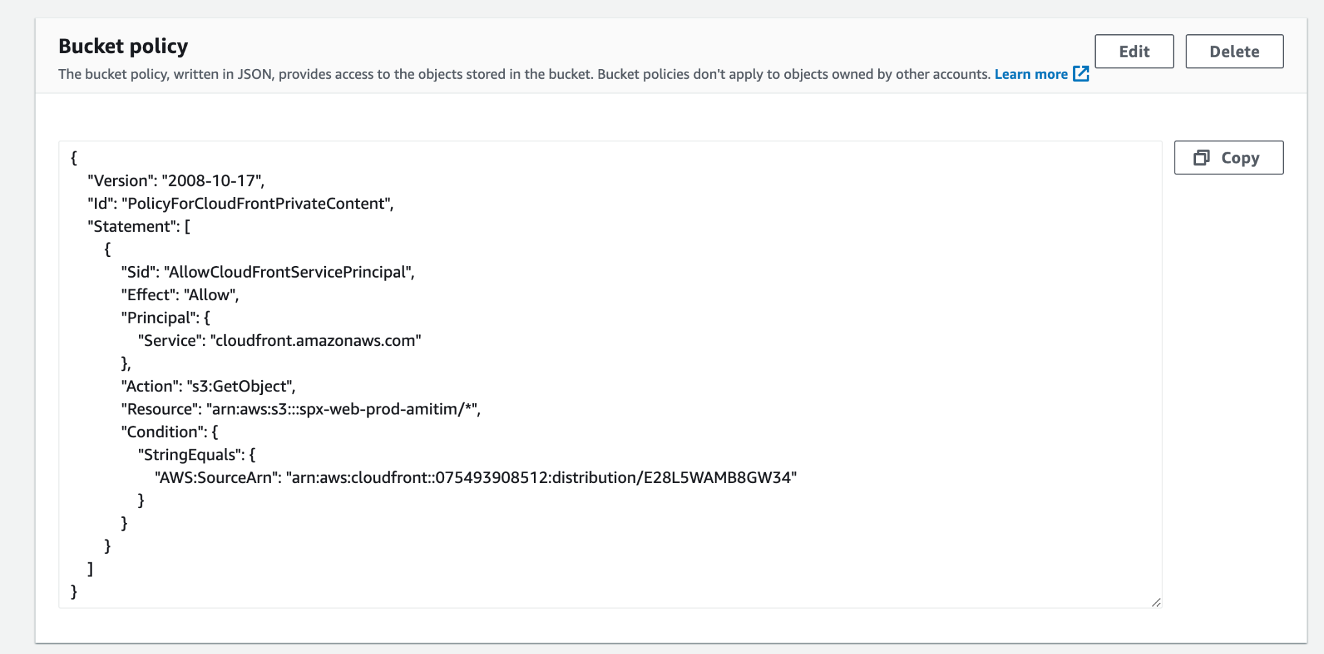
{
"Version": "2008-10-17",
"Id": "PolicyForCloudFrontPrivateContent",
"Statement": [
{
"Sid": "AllowCloudFrontServicePrincipal",
"Effect": "Allow",
"Principal": {
"Service": "cloudfront.amazonaws.com"
},
"Action": "s3:GetObject",
"Resource": "arn:aws:s3:::spx-web-prod-plarium/*",
"Condition": {
"StringEquals": {
"AWS:SourceArn": "arn:aws:cloudfront::075493908512:distribution/E28L5WAMB8GW34"
}
}
},
{
"Sid": "2",
"Effect": "Allow",
"Principal": {
"AWS": "arn:aws:iam::cloudfront:user/CloudFront Origin Access Identity ETC78JLNIEO9H"
},
"Action": "s3:GetObject",
"Resource": "arn:aws:s3:::spx-web-prod-plarium/*"
}
]
}

- Below that also add

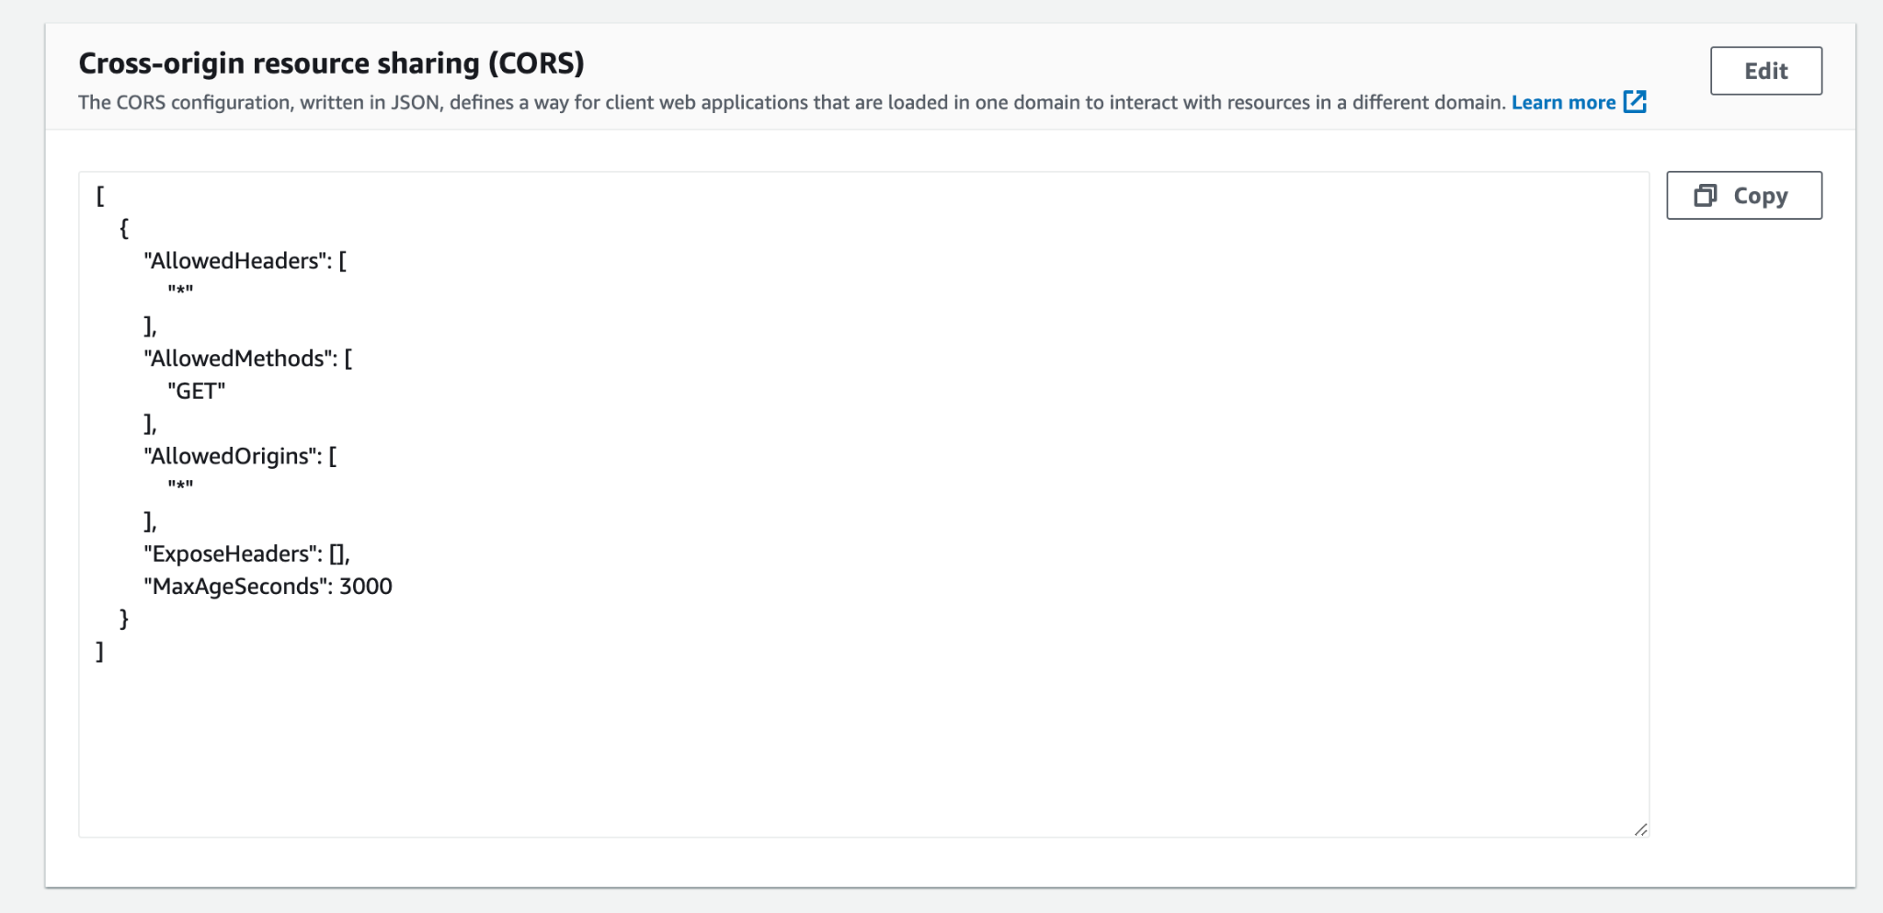
[
{
"AllowedHeaders": [
"*"
],
"AllowedMethods": [
"GET"
],
"AllowedOrigins": [
"*"
],
"ExposeHeaders": [],
"MaxAgeSeconds": 3000
}
]

CloudFront
- Go to CloudFront from the AWS Console
- Create new web distribution
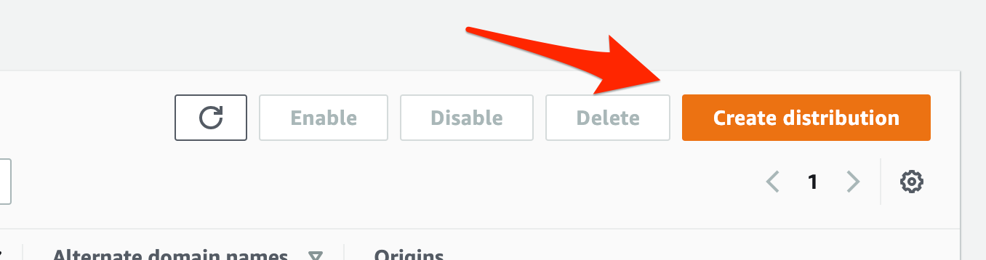
- Define the following settings
  - Origin
- Origin domain = spx-web-prod-plarium.s3.eu-central-1.amazonaws.com (the bucket we just created)
- Origin Domain Name = Same as Origin Domain (spx-web-prod-plarium.s3.eu-central-1.amazonaws.com)
- Origin access = “Origin access control settings: Legacy access identities”
- Origin access control = Click “Create control settings”
  - Keep settings for “Sign requests (recommended)”
  - Origin type: S3
- Grant Read Permissions on Bucket = Yes, Update Bucket Policy
It should look like this after you’re finished:
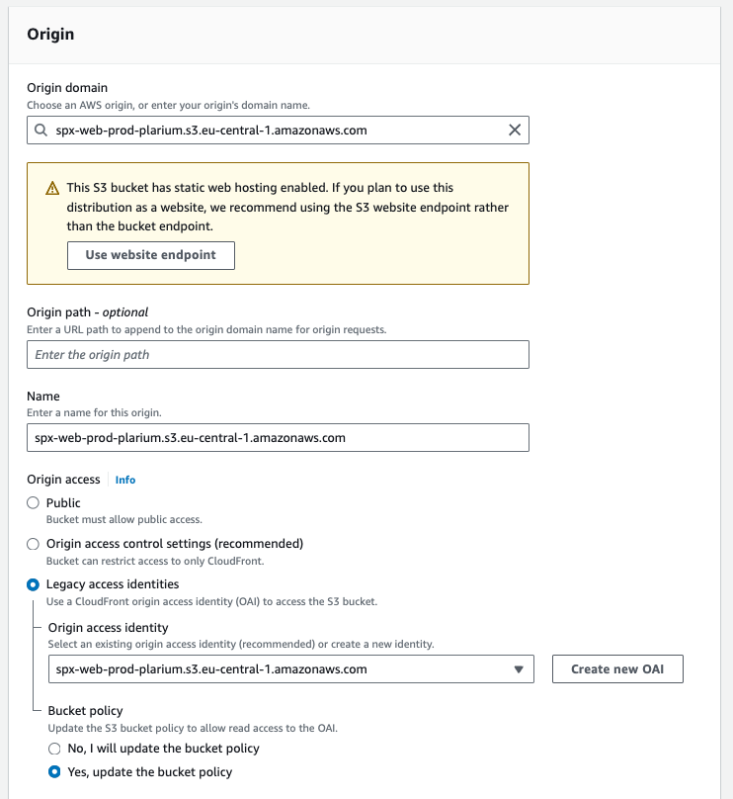
One should create a new OAI
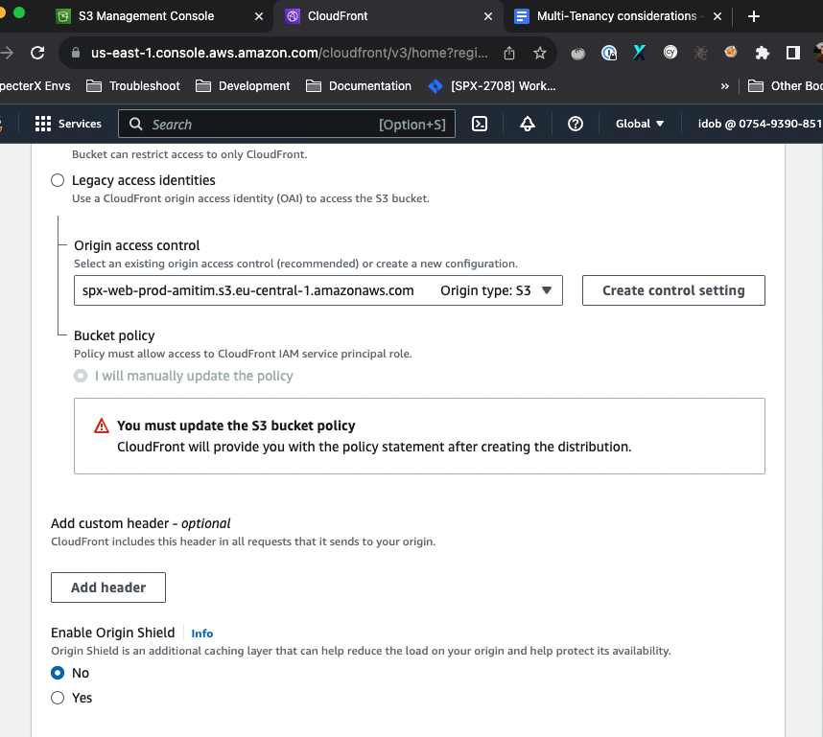
  - Default Cache Behavior Settings
- Compress Objects Automatically = Yes
- Viewer Protocol Policy = Redirect HTTP to HTTPS
- Allowed HTTP Methods = GET, HEAD, OPTIONS
- 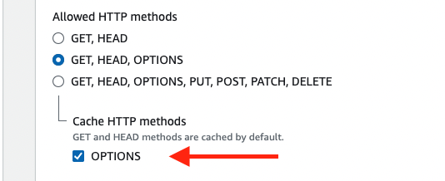
- Cache key and origin requests - OPTIONS
  - Function Associations
- CloudFront Event = Viewer Response
- Lambda Function ARN =
  - For all our tenants we used this Lamba, which is under us-east: arn:aws:lambda:us-east-1:075493908512:function:security_headers:14
  - For our multi-tenant, we should probably switch to a Lambda that’s on eu-central-1, same as all our Lambdas.
Some reading materials here.
And here.
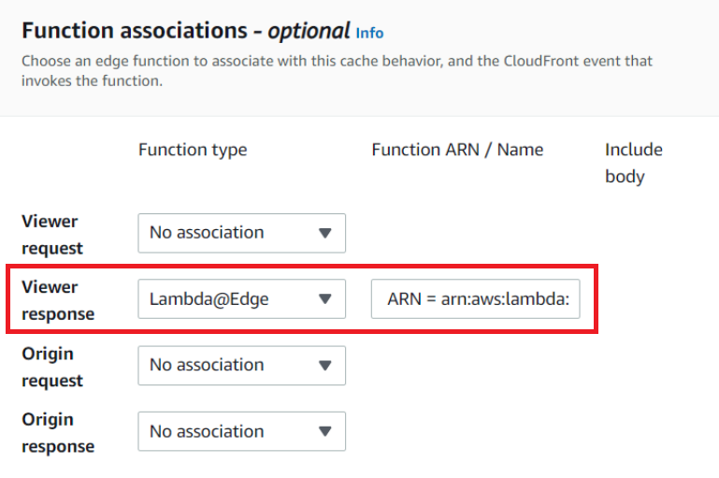
  - WAF?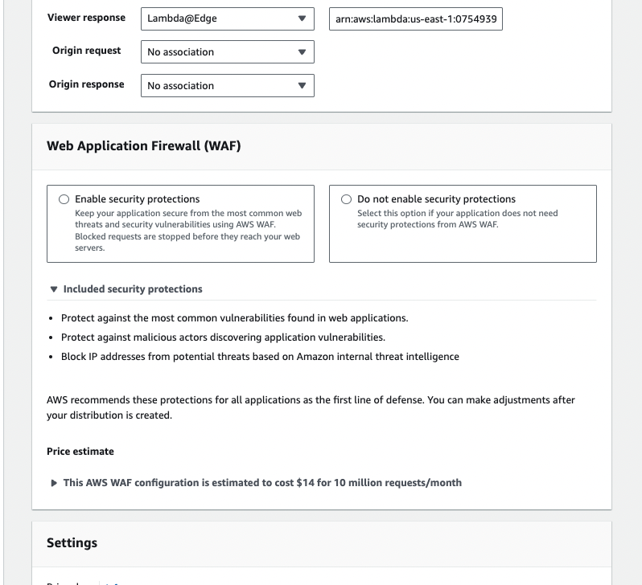
  - Distribution Settings
- Alternate Domain Names (CNAMEs) = plarium.specterx.com (enter the name of the web application)
- SSL Certificate
  - Custom SSL Certificate (example.com)
  - *.specterx.com (e5fe55c1-e50c-4b7f-b18d-aca205f655e3)
- Default Root Object = index.html
- Description = production plarium
- Click “Save and Create”.
- Save distribution domain name and ID for later.
- Go to the newly created distribution.
- Go to the “Error pages” tab and create 2 custom error pages

  - HTTP Error Code: 403 Forbidden
    - Customize Error Response: Yes
    - Response Page Path: /index.html
    - HTTP Response Code: 200 OK
  - HTTP Error Code: 404 Not Found
    - Customize Error Response: Yes
    - Response Page Path: /index.html
    - HTTP Response Code: 404 Not Found

Route53 DNS record
Go to SpecterX hosted zone in Route53 https://console.aws.amazon.com/route53/v2/hostedzones#ListRecordSets/Z2ZIJPQ1FB5142

- Create a CNAME records with the name of the tenant plarium.specterx.com that points to cloud front distribution domain
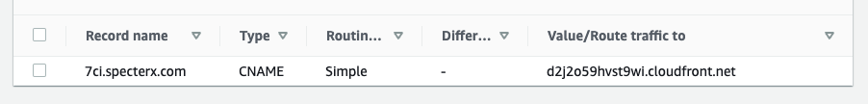

Cognito - Part 1

Create new Cognito User Pool
- Create new Cognito User Pool with these parameters
- Pool name = plarium-users-prod (for example: blackpoint-users-prod)
Step through settings

Step 1
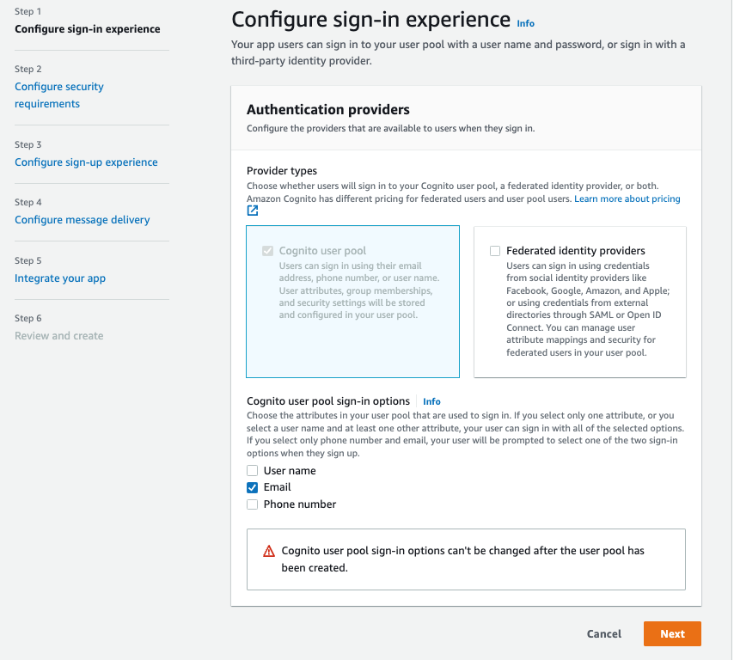

Step 2
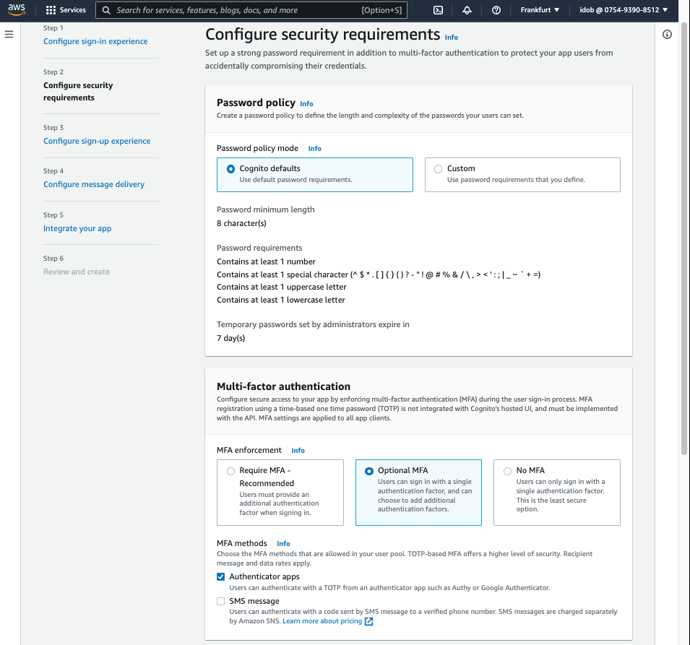
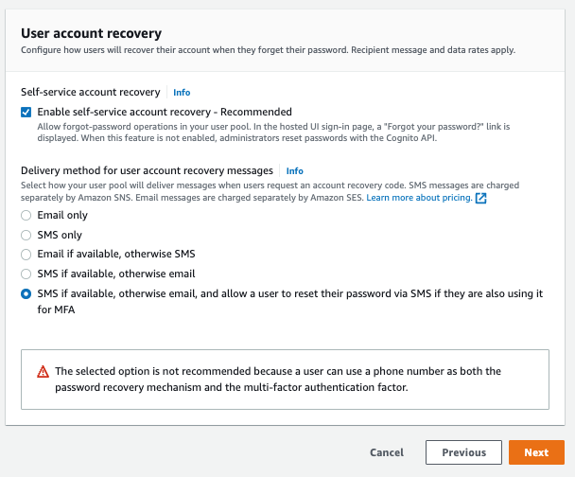

Step 3
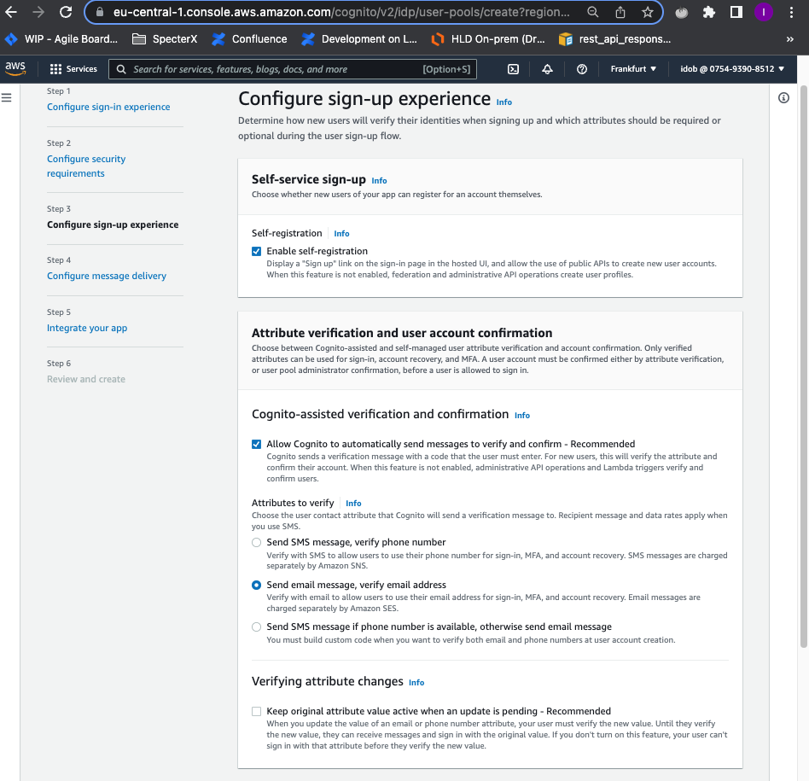
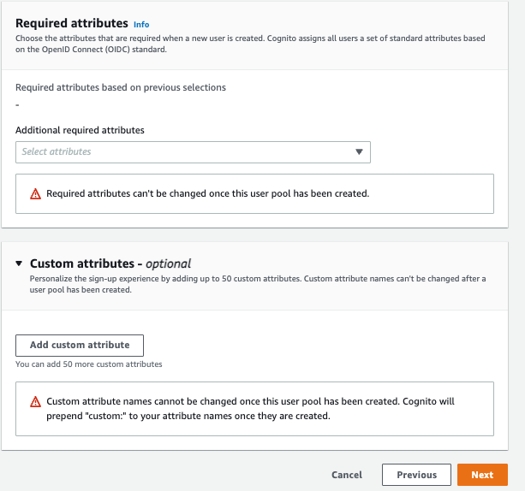
Step 4
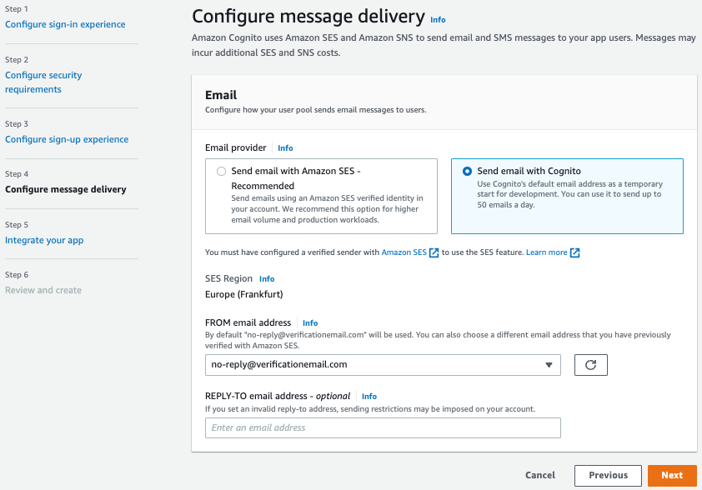

Step 5
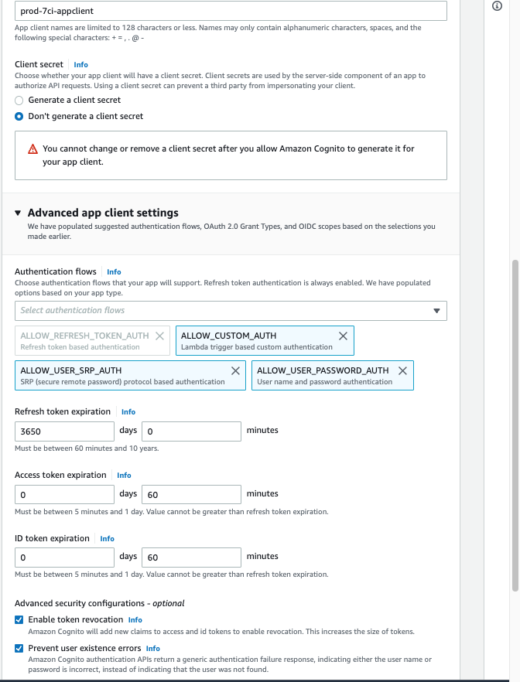
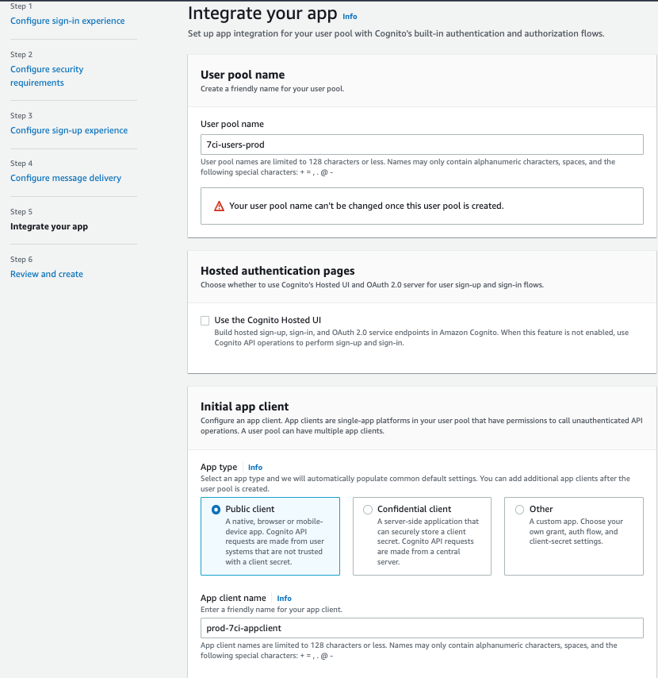
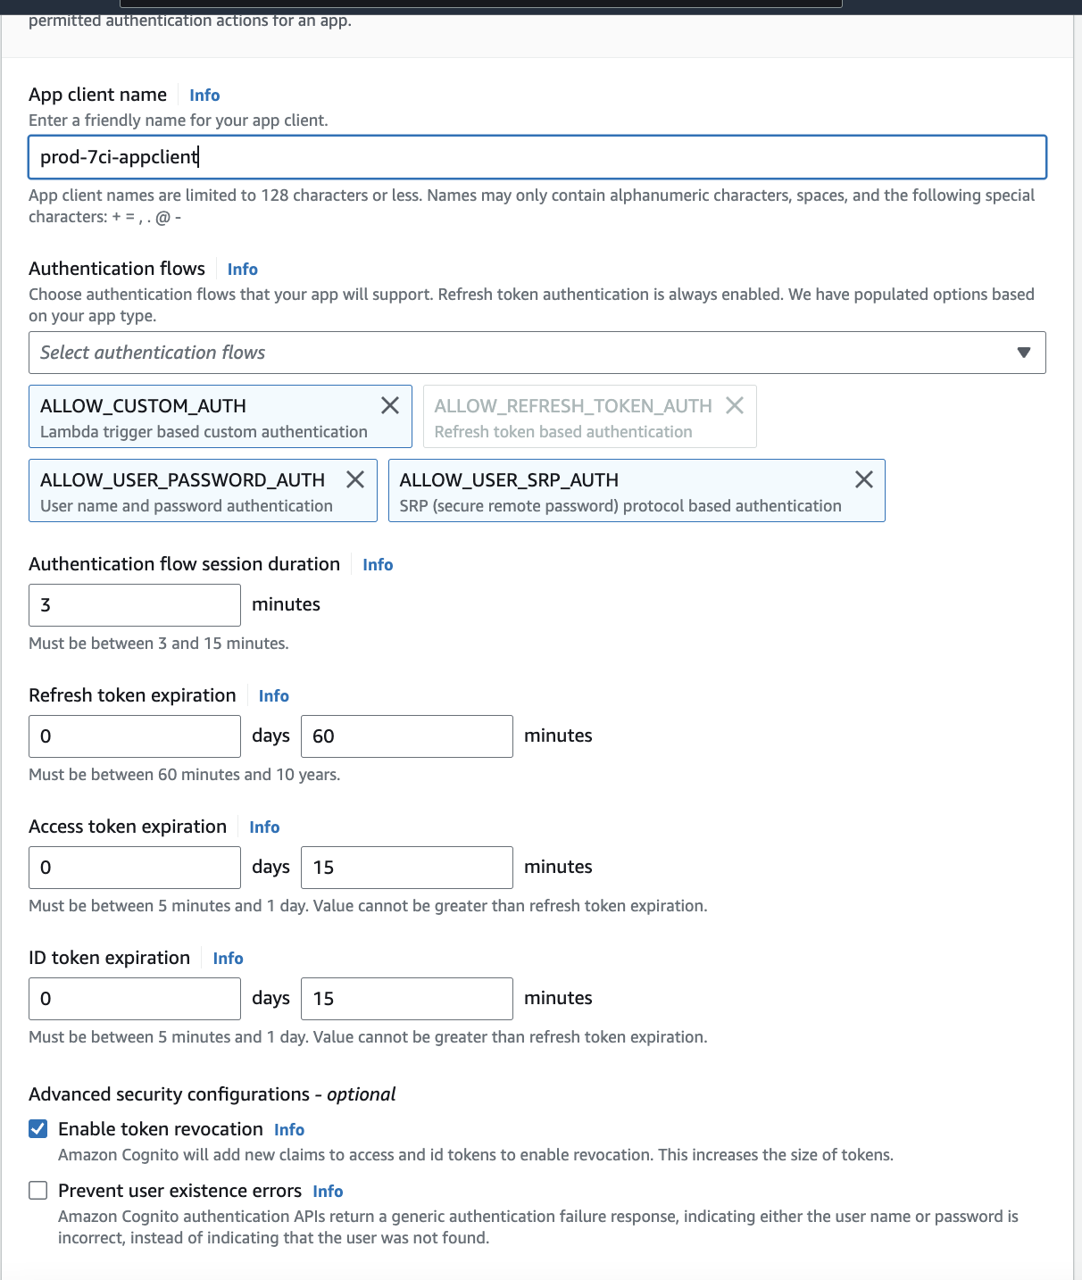

Attributes
- Radio buttons - Email address or phone number
  - Allow email addresses
- Uncheck - Enable case insensitivity
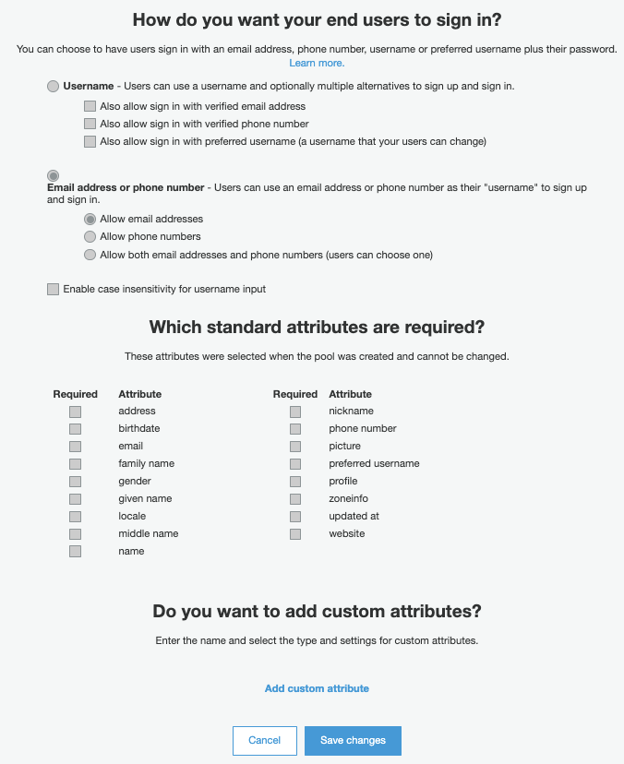

Policies
- Leave as default

MFA and Verifications
- Do you want to enable Multi-Factor Authentication (MFA) = Optional
- Which second factors do you want to enable = Time-based One-time Password
- How will a user be able to recover their account = (Not Recommended) Phone if available, otherwise email, and do allow a user to reset their password via phone if they are also using it for MFA.
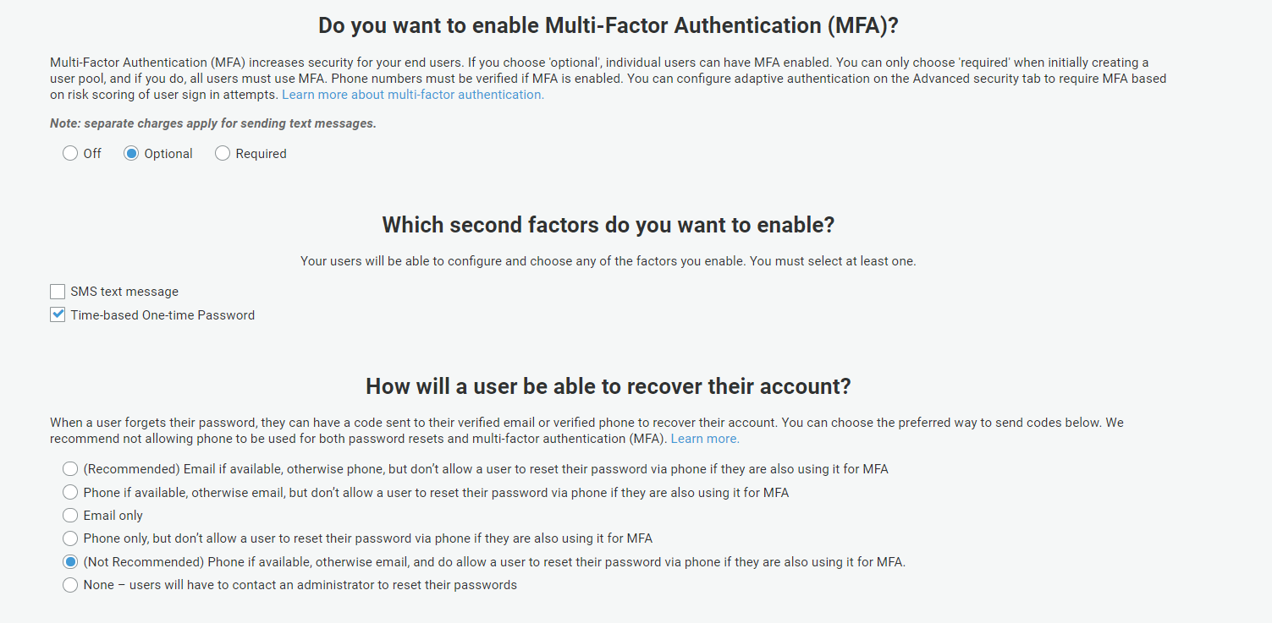
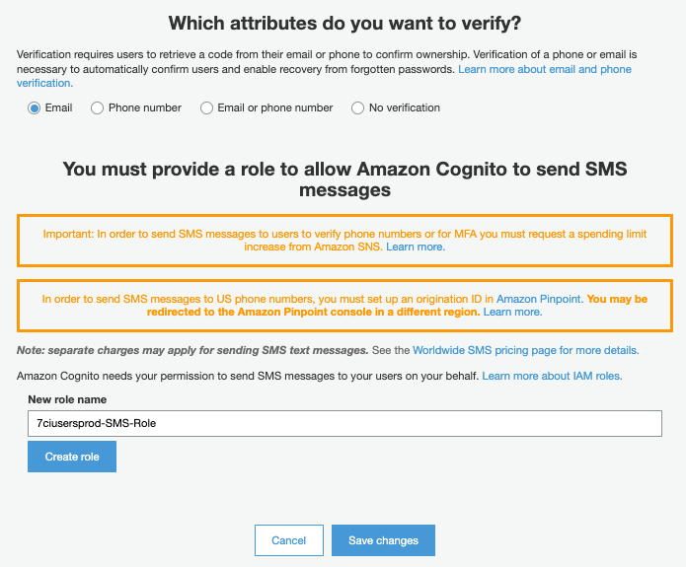
(no need to create Role)

Tags
- Add key and value = STAGE: prod-plarium (for example: prod-blackpoint)
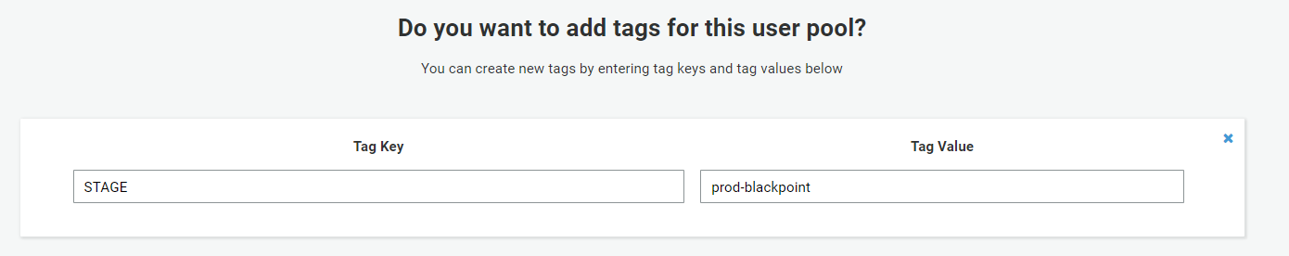

At this point Create the user pool

Message Customizations
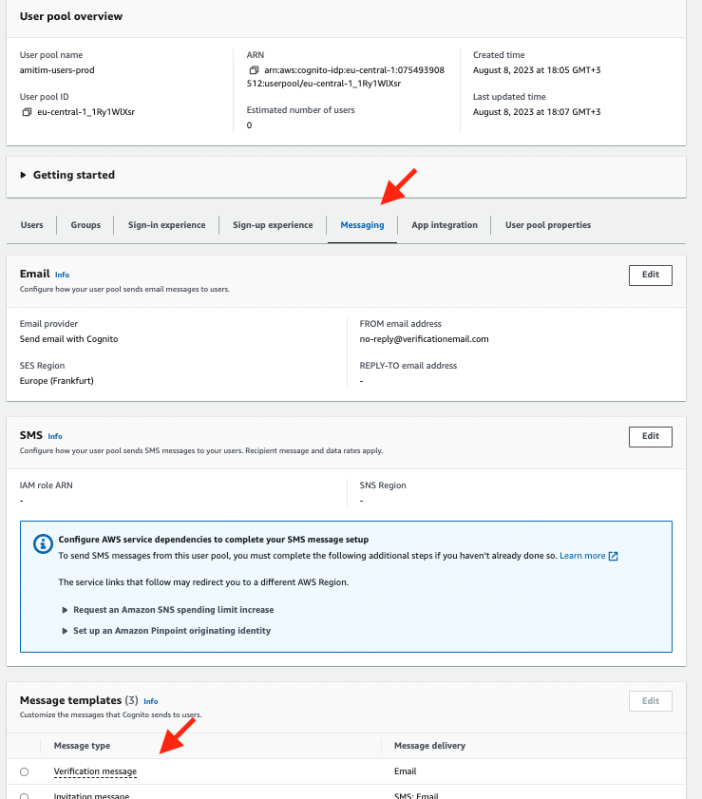
- Do you want to customize your email verification messages = Yes
  - Verification type = Link
  - Email subject = SpecterX - Verify your email address
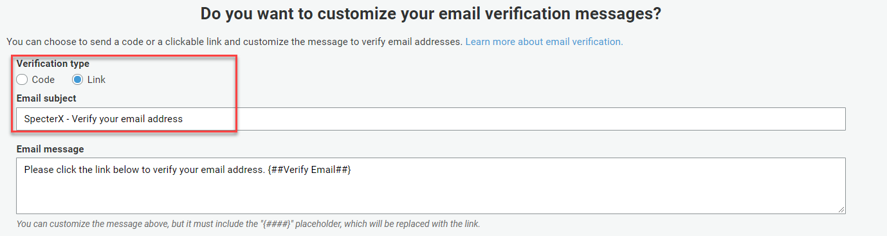

Devices
- Leave default

App clients
Select “Add an app client” and create with with these parameters:
- App client name = prod-plarium-appclient (for example: prod-blackpoint-appclient)
- Refresh token expiration = 3650 days
- Generate client secret = Uncheck
- Auth Flows Configuration
  - ALLOW_CUSTOM_AUTH
  - ALLOW_USER_PASSWORD_AUTH
  - ALLOW_USER_SRP_AUTH
  - ALLOW_REFRESH_TOKEN_AUTH
- Security configuration - Legacy
  - For the new tenant we’ll create for Multi-Tenancy, we should use the recommended value.
- Click - Create app client
- Save App client id for later (Save in the table)

Triggers (User pool properties)
Leave it as it is for now.
This part must be done after we deploy environment services.

- Create User Pool and copy Pool Id for later (Save in the table)

App Integration
App client settings

- Enabled Identity Providers = Select All
- Sign in and sign out URLs (both for Callback and Sign out URLs) =
http://localhost:3000, http://localhost:3000/signin, https://plarium.specterx.com, https://plarium.specterx.com/gdrive/share, https://plarium.specterx.com/signin
E.g = http://localhost:3000, http://localhost:3000/signin, https://7ci.specterx.com, https://7ci.specterx.com/gdrive/share, https://blackpoint.specterx.com/signin
- OAuth 2.0
  - Allowed OAuth Flows = Authorization code grant, Implicit grant
  - Allowed OAuth Scopes = Check all

Domain name

Domain prefix = https://plarium-users.auth.eu-central-1.amazoncognito.com
E.g https://blackpoint-users.auth.eu-central-1.amazoncognito.com
Save it for later

Create custom domain in App integration
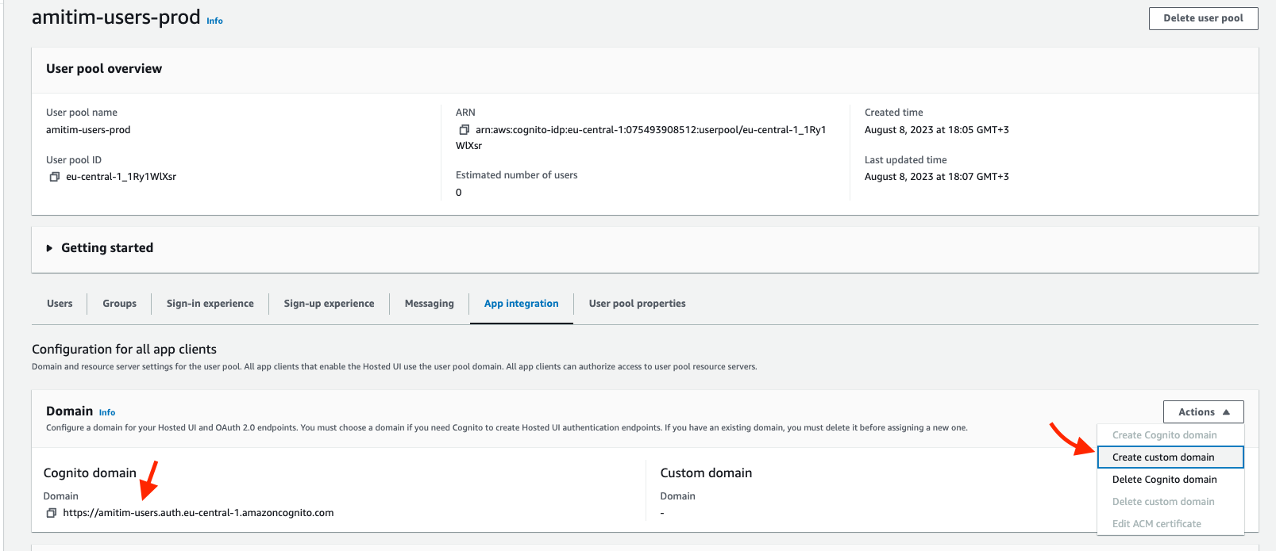

Cognito Identity Pool
- Go to the production Identity Provider and navigate to the ‘User access’ tab
- Click ‘Add identity provide’ for prod_authorizer: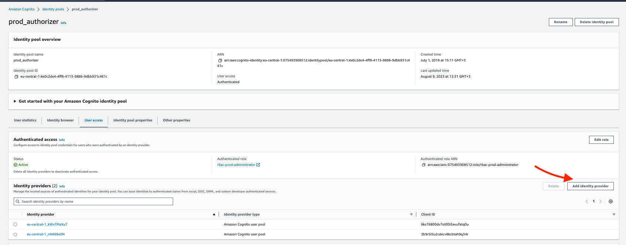
- Use the Cognito Pool ID that was created for this tenant.
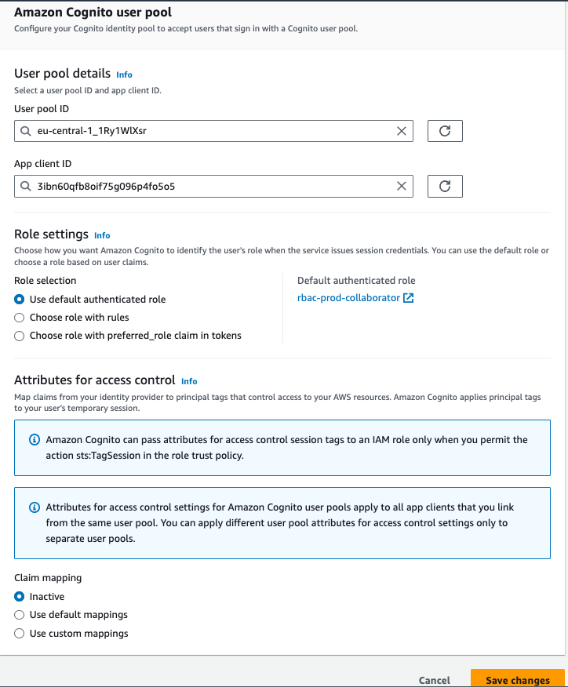

SaaS Dependencies
These dependencies need to be set up before moving on to configuring the code base, as some elements depend on the existence of these resources.

Courier
TODO - Add documentation

Flagsmith
- Go to https://app.flagsmith.com/
- Login with specterx google, enter specterx
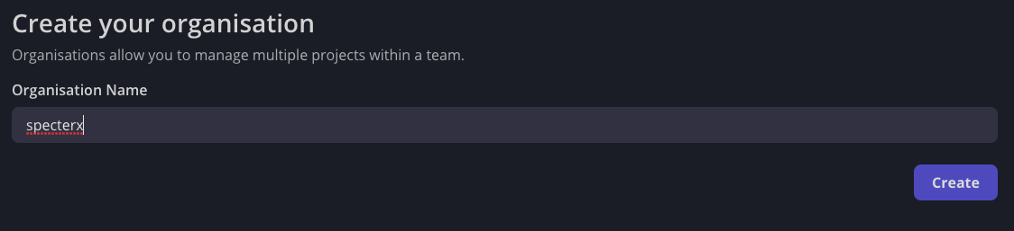
- Click on the ‘+’ next to ‘Envrionments’ to create a new environment.
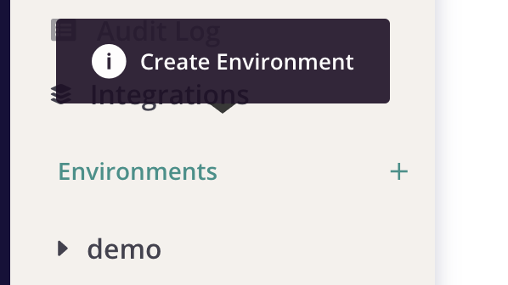
- Give the new environment a name that matches the tenant name (prod-xxxx).
Clone configurations from the most similar tenant based on the defined use-case, or just take the latest tenant that was built.
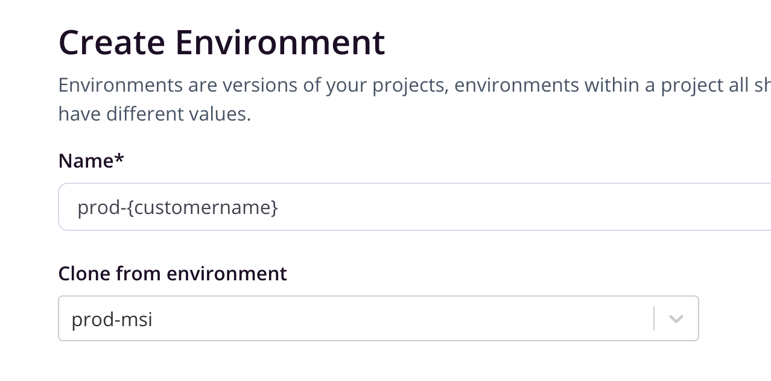
- Click ‘Create Environment’
- From the sidebar, open the options for the newly created environment and choose Settings
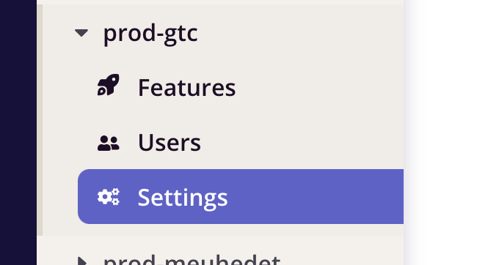
- Copy the API key and keep it until you need in the next steps of updating the tenant configurations in SystemConfig.yml.
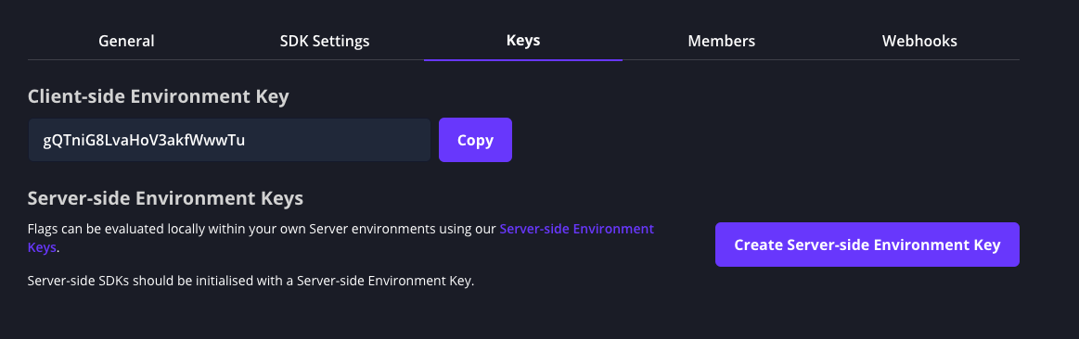

Codebase

Update the common Configuration repository
- Use VS Code / SourceTree to connect to SpecterX bitbucket.
- Clone the repositories (Configuration + all below) - you can clone only the devops-tools repository, and then use the script .devops-tools/local/utils/get-repos.sh (it should download all the following repositories)
  - common_modules
  - cloud_apps
  - download-service (AKA access service)
  - aip-management-service
  - aip-encryption-service (aip iis site)
  - auth-service
  - audit-service
  - entities-service
  - files-sync-service
  - organizations-service
  - settings-service (AKA admin service)
  - upload-service
  - links-service
  - wopi-api
make sure to set all repositories to ‘Staging’ branch. You can use .devops-tools/local/utils/specterx-all-repos-git-actions.sh
- Optional: Use VS Code to edit the files below

Configuration repo - git@bitbucket.org:specterx/configurations.git

Environments.yml
Add the new environment name to Environments.yml
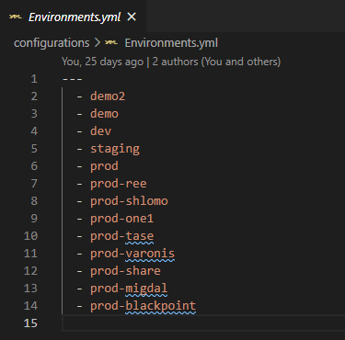

SystemConfig.yml
Add the new environment to each of the settings in SystemConfig.yml and add the correct value for each one of them(except for the services: aip_logs_tenant_id, aip_logs_client_id, aip_logs_client_secret, aip_logs_log_workspace, sharepoint_mediation_client_id, sharepoint_mediation_client_secret, wopi_server, flagsmith_environment_id, sharepoint_mediation_site_url
- which we will define later, for now set them to UNDEFINED)
Important note - We don’t use most of the settings here since they are related to our old solution. Since we had not removed them it makes this process long and stupid.
Example.
- For every config, use pretty much the same configuration as the others.

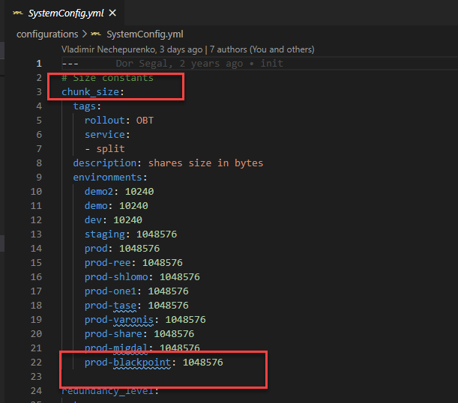

For example to add all NEW-ENV: UNDEFINED use (cmd+shift+r)

Push it to the master branch.
There is an automatic Jenkins job that will publish these parameters into AWS SSM
After adding in Environments.yml and SystemConfig.yml new configurations we need
to deploy them in Jenkins https://ci.spx.com/job/deploy-configuration/

Update specific configuration files in each repository
In this section, you will define the new tenant in all the configuration and Jenkins files, and then create a branch of each one of the code-repositories for the new tenant.

When updating the configuration files, use the following naming convention for production tenants (the same convention will later be used to create the new branches):

master-plarium

For example: master-nta or master-shikunbinui

What repos will we update and create a branch for?
At the time of writing, these are the relevant repos (but there might be more):

Microservice repositories
- download-service (AKA access service)
- aip-management-service
- aip-encryption-service (aip iis site)
- auth-service
- audit-service
- entities-service
- files-sync-service
- settings-service (AKA admin service)
- upload-service
- links-service
- wopi-api (this one is configured a bit differently, look here)

Web client repository
- Web-client

Outlook addin repository
- outlook-addin
- Following our new gitflow method, all the additional parameters for unique tenants should be made directly on the master branch, and not on the master-tenant branch.

Microservice repositories

Jenkinsfile
All repos have a Jenkinsfile. Simply replicate the generic one in master, that has a default switch case for any tenant name other than our ones.

Example:
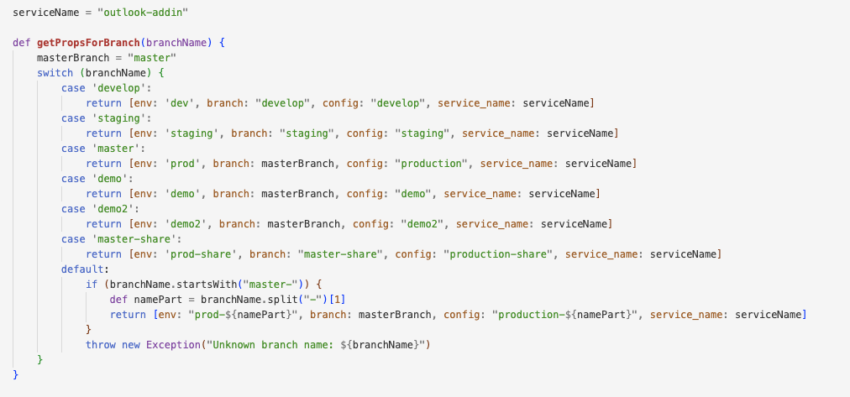

Serverless.yml
cognito - Only apply with services with this section
Add the environment and its cognito user pool

Example:
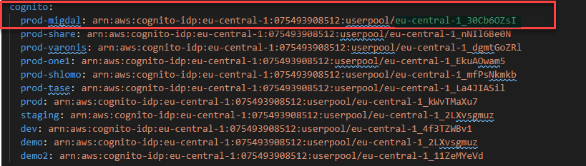

Domains - Only applies for services who has REST API
Add the environment name and the backend api for this environment.

Example:
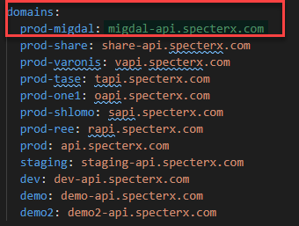

Python requirements file
Duplicate one of the requirements txt file, rename it and change it content accordingly
example

Web client repository

env.ts
Edit ./src/config/env.ts file - copy another configuration block and change name and values accordingly. Add env to the big if statement at the end of the file like the others
- If you don’t have Microsoft / Google - set it to ‘missing’

const plarium: EnvConfig = {
COMPANY_LOGO: '/assets/company_logo/plarium-logo.png',
HEADER_COMPANY_LOGO: '/assets/header_company_logo/plarium-logo.png',
HEADER_SMALL_COMPANY_LOGO: '/assets/header_company_logo/small_logos/plarium-small.svg',
API_URL: 'https://plarium-api.specterx.com',
APP_URL: 'https://plarium.specterx.com',
cognito: {
USER_POOL_ID: 'eu-central-1_rs6vEDwTX',
APP_CLIENT_ID: 'b43qloq0lfugh8btb8c94nf05',
IDENTITY_POOL_ID: 'eu-central-1:4e0c2de4-4ff8-4113-9886-9dbb931c461c',
DOMAIN: 'plarium-users.auth.eu-central-1.amazoncognito.com',
},
SSO: [SSOTypes.cognito, SSOTypes.google, SSOTypes.okta],
ENABLE_IP_RESTRICTION: true,
UPLOAD_FILES_COUNT_LIMIT: 50
};

Example:

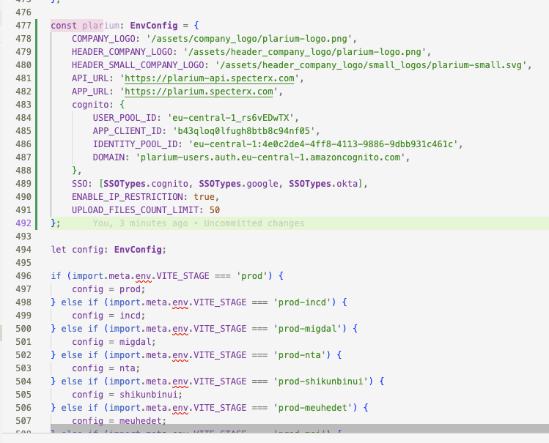

Jenkinsfile
Copy configuration block and edit name and value
- Env: the name of the environment
- Branch: branch name for this env
- Cfid: Cloudfront id - the Cloudfront instance which the frontend application is hosted
- Bucket: S3 bucket containing the application files

example
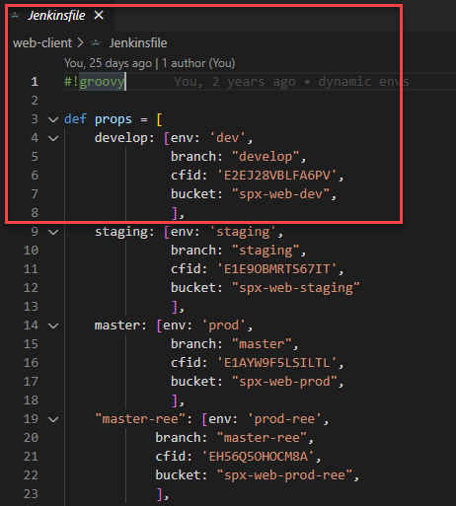

Create new Branches for the tenant

Create branches
Create a branch with this name of the environment. For production the convention is like this
(all lowercase letter) - master-plarium

For example - master-nta or master-shikunbinui

Do this for all the microservices repos, as well as for common-modules.
All micro-service repos can be found here: https://bitbucket.org/specterx/workspace/projects/MIC

The branches for libraries (common-modules and cloud-apps) should be created and pushed first.

Push all branches to remote
Once finished with modifying all the repositories and configuration files:
- Push the changes to the ‘Staging’ branch (using VS Code / SourceTree)
  - common_modules
  - cloud_apps
  - download-service
  - aip-management-service
  - aip-encryption-service
  - auth-service
  - audit-service
  - entities-service
  - files-sync-service
  - settings-service
  - upload-service
  - links-service
  - web-client
- After creating all branches, push them to all repositories

Creating a branch from BitBucket GUI should look something like this:

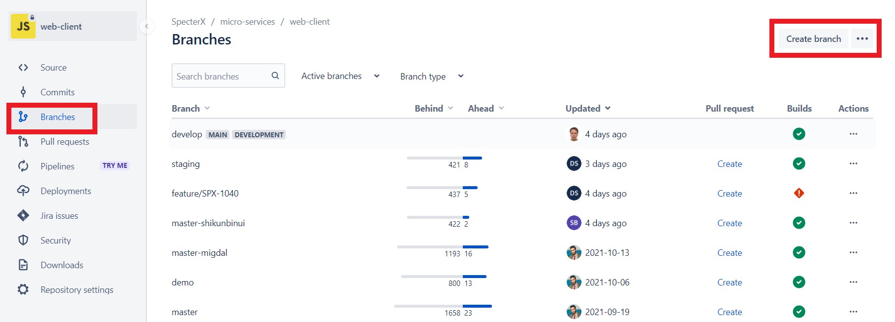
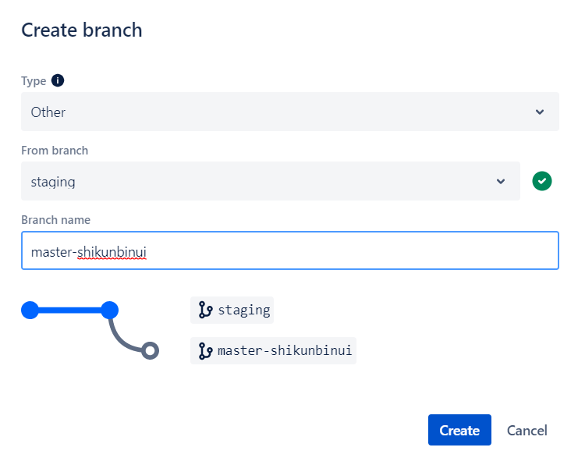

Creating a branch from CLI ( git must be installed ):
You can create a branch locally as long as you have a cloned version of the repo.

- From your terminal window, list the branches on your repository.
$ git branch
* develop
This output indicates there is a single local branch, the develop and the asterisk indicates it is currently active.
- Create a new feature branch in the repository
$ git branch <feature_branch>
- Switch to the feature branch to work on it.
$ git checkout <feature_branch>
You can list the branches again with the git branch command.
- Commit the change to the feature branch:
$ git add .
$ git commit -m "adding a change from the feature branch"
- Switch back to the main branch.
$ git checkout develop
- Push the feature branch to Bitbucket:
$ git push origin <feature_branch>
- View the Source page of your repository in Bitbucket. You should see both the main and the feature branch. When you select the feature branch, you see the Source page from that perspective. Select the feature branch to view its Recent commits.

Update Jenkins automated builds
- Login into Jenkins - ci.spx.com (vpn required)

Create a tab for the new branch (through Jenkins)
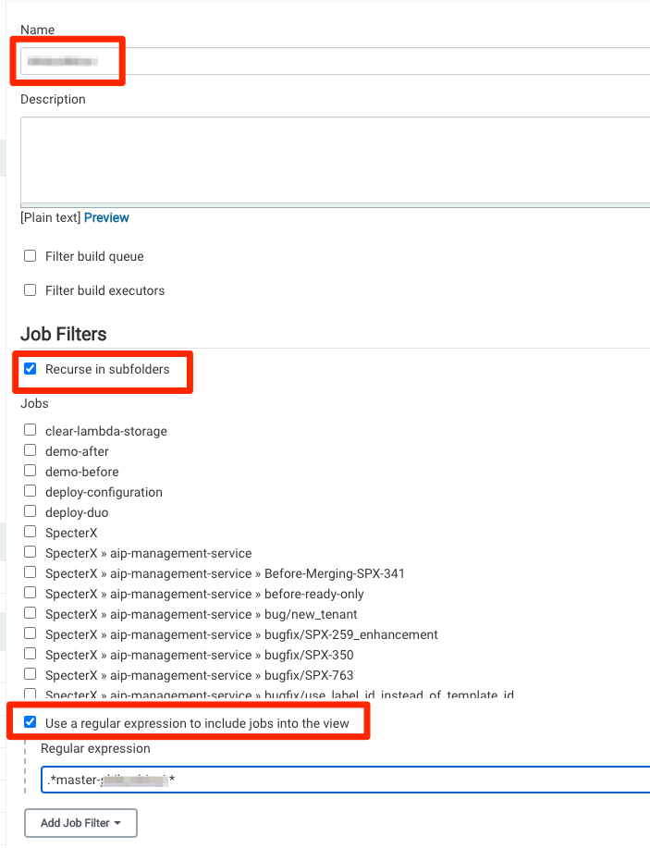
- Click on SpecterX project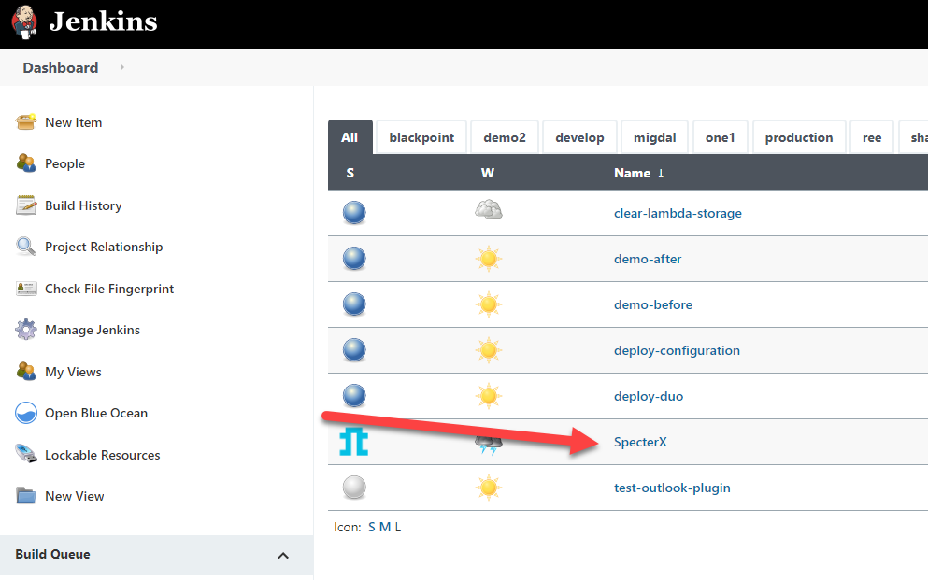

- Scan Organization - this will trigger all builds for the new branch
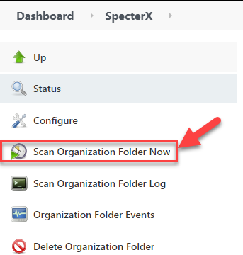

API Gateway

Register Custom domain name in DNS
Go to: AWS > API Gateway> Custom domain names
- Mark plarium-api.specterx.com domain and copy API Gateway domain name:
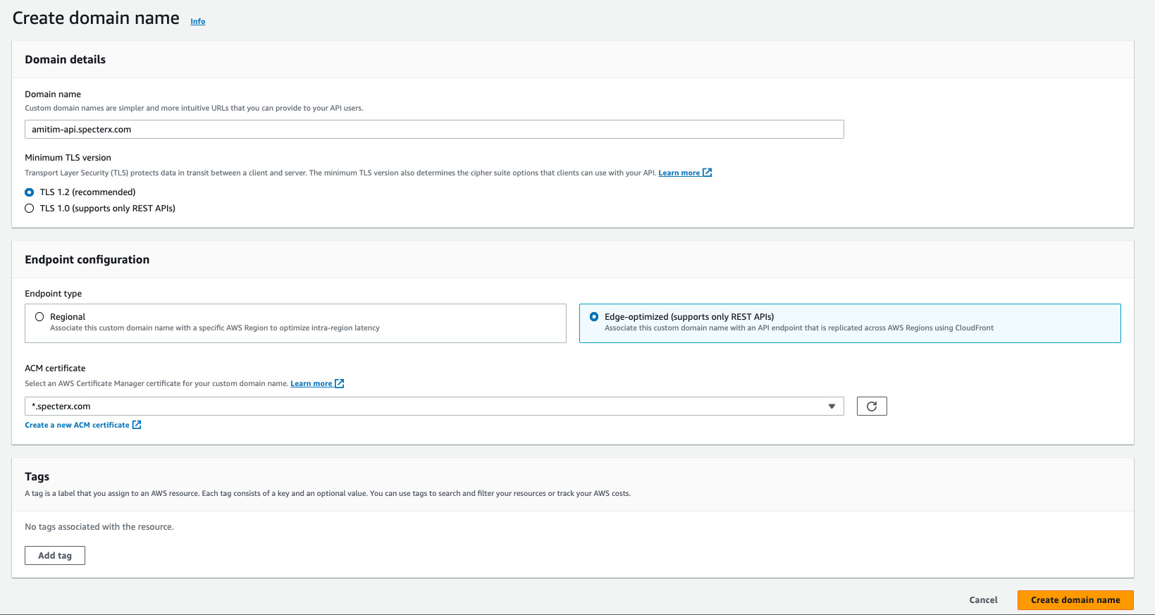
*.specterx.com (e5fe55c1-e50c-4b7f-b18d-aca205f655e3)
Then you should see
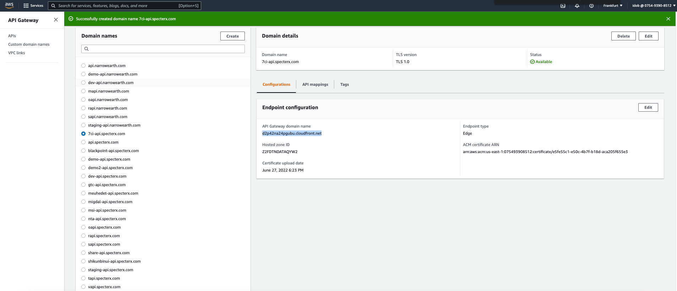

Now go to:
https://console.aws.amazon.com/route53/v2/hostedzones#ListRecordSets/Z2ZIJPQ1FB5142
Create new CNAME record:
- Record name: plarium-api
- Record type: CNAME
- Value: API Gateway domain name (that you just copied)
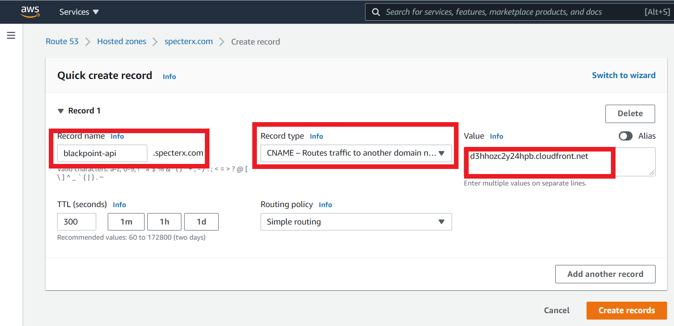

Usage Plans
Create usage plan for new tenant like following:
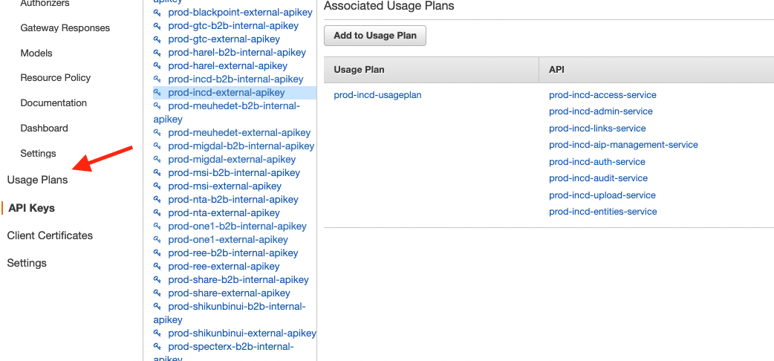
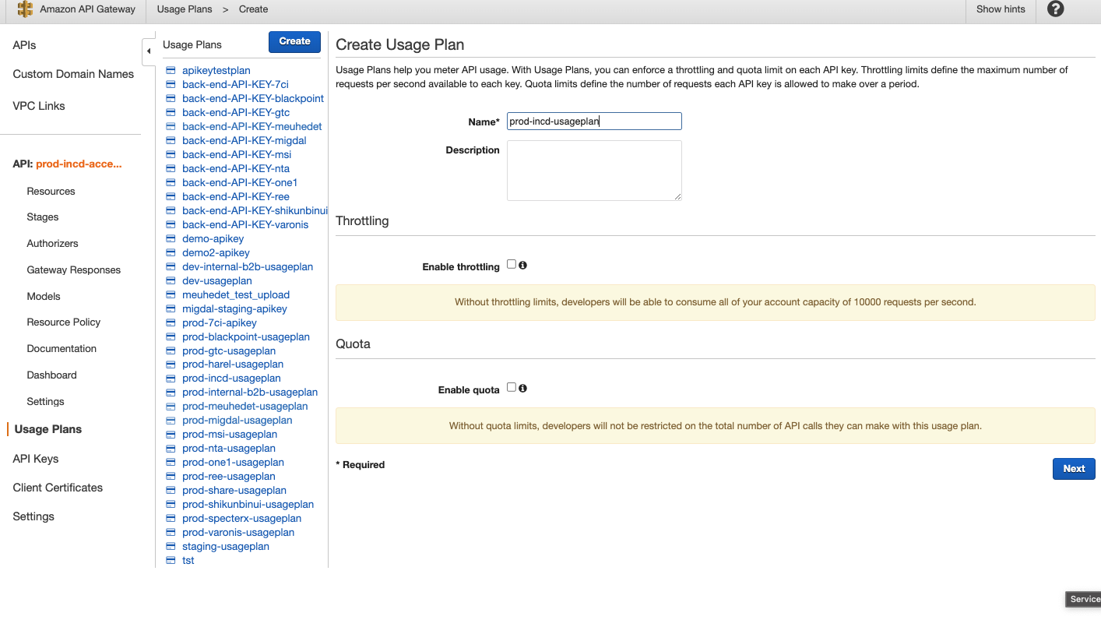

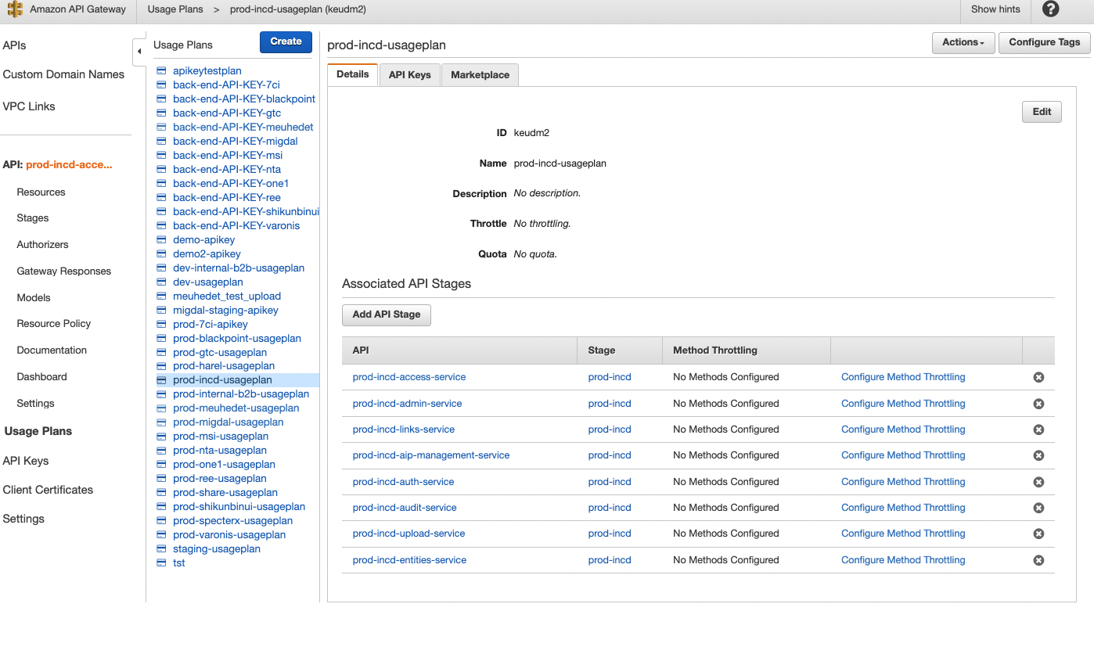

Rabbit MQ
We should add the new tenant title in configurations/configurations/RabbitMqQueues.yml

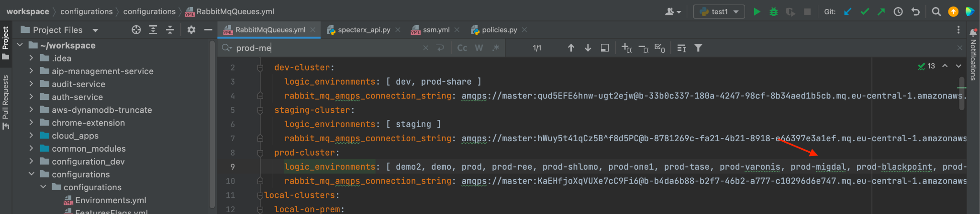

Need to make sure that all lambdas triggered by RabbitMQ, trigger is enabled
For example for: audit-service-prod-amitim-add-log-to-audit-async-mq
https://eu-central-1.console.aws.amazon.com/lambda/home?region=eu-central-1#/functions/audit-service-prod-amitim-add-log-to-audit-async-mq?tab=configure
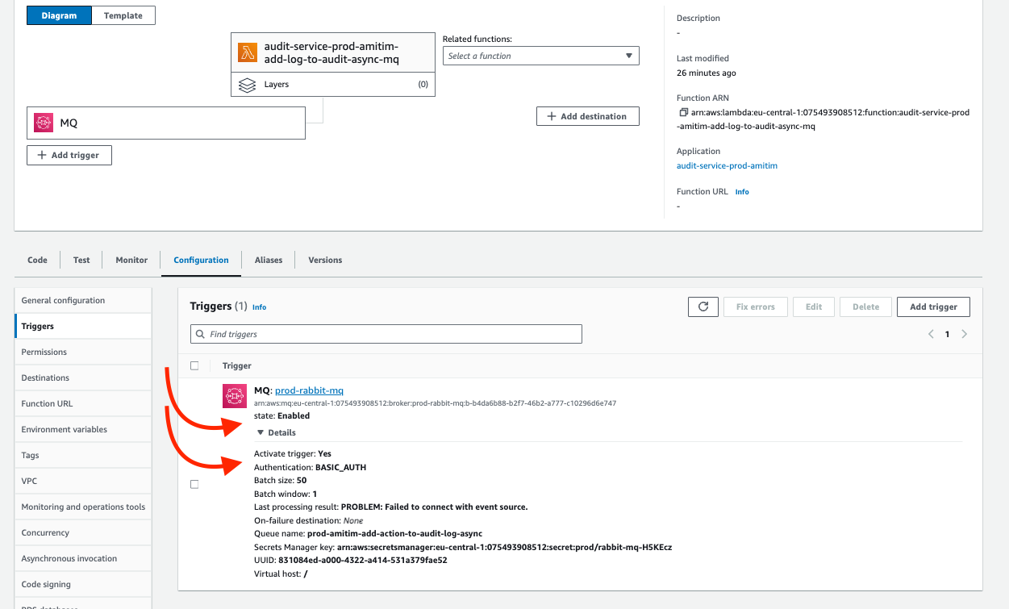
Here is a list of necessary lambdas today(might change every day):
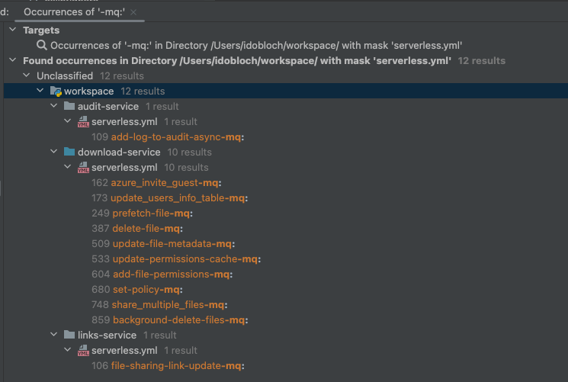
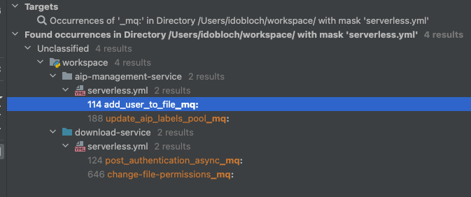

Connecting AWS resources to each-other

Cognito - Part 2

Create Groups
Create groups for each role and attach corresponding IAM role
AWS>Cognito>Manage User Pools> plarium-users-prod>Users and groups>Groups
In case the Role is missing from the UI, Set it using the following AWS CLI:

From now on all cognito pool groups will use IAM of production
- Administrators - rbac-prod-administrator
- Collaborators - rbac-prod-collaborator
- Externals - rbac-prod-external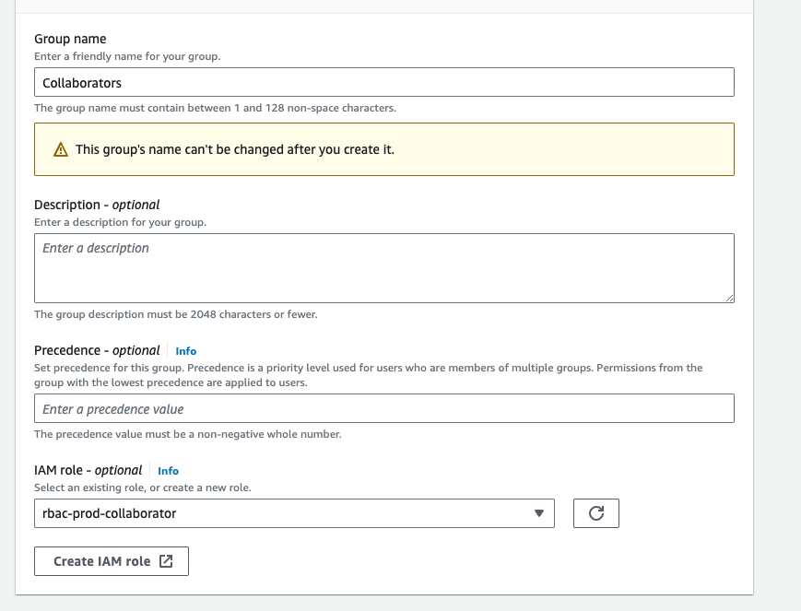
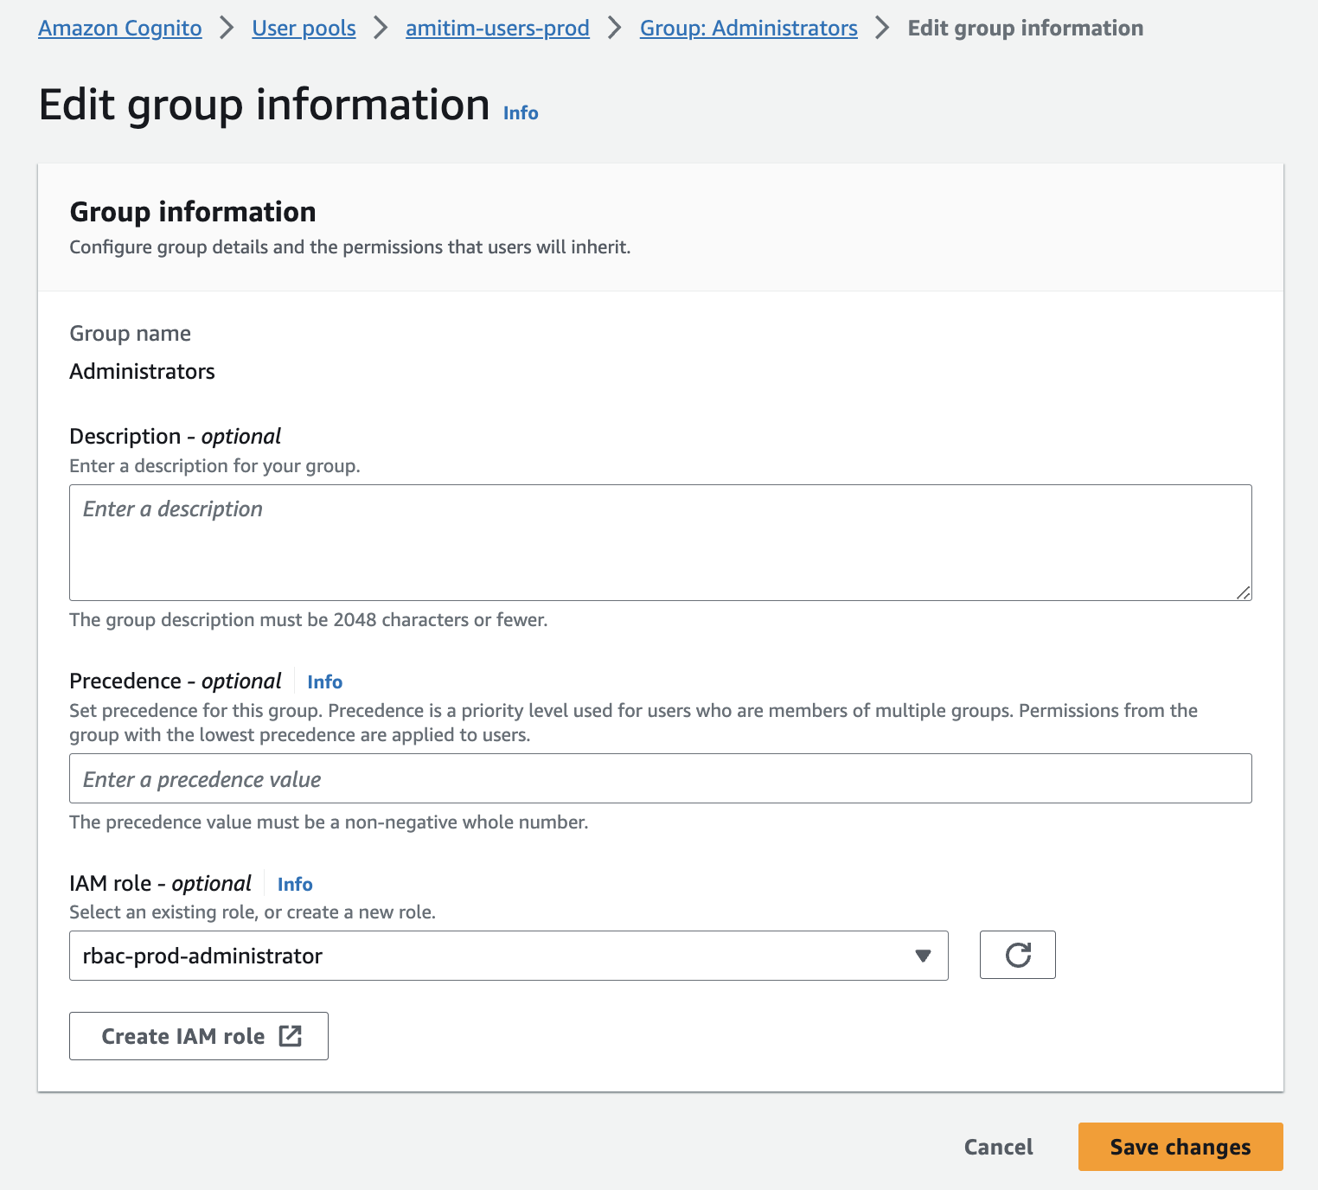

Set up Triggers in Cognito
Note 1: **This can be done only after Access and Auth services are deployed**

Go to the new User Pool and select ‘Triggers’ from the sidebar
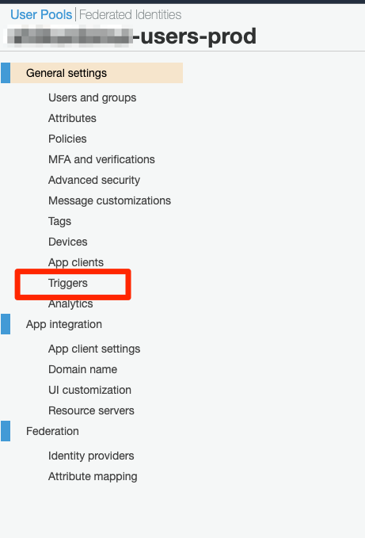
A lot of triggers doesn’t show when you open the dropdown(randomly), so you should always click the ‘Load more…’ option:
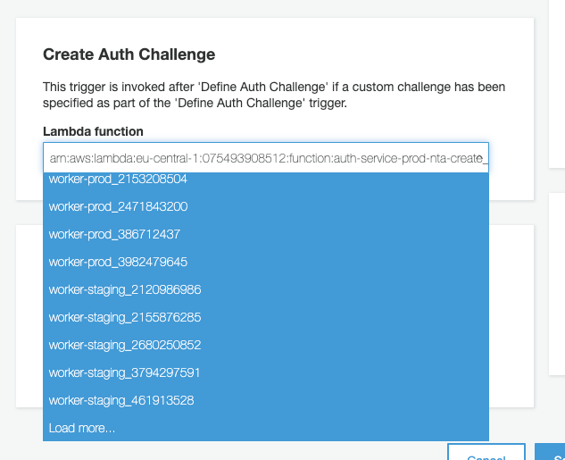

Setup those triggers with the corresponding functions:
- Pre sign-up - access-service-prod-prod-plarium-pre_signup
- Post authentication - access-service-prod-prod-plarium-post_authentication
- Post confirmation - access-service-prod-prod-plarium-post_confirmation
- Pre Token Generation - access-service-prod-prod-plarium-pre_token_generation
- Define Auth Challenge - auth-service-prod-prod-plarium-define_auth_challenge
- Create Auth Challenge - auth-service-prod-prod-plarium-create_auth_challenge
- Verify Auth Challenge Response - auth-service-prod-plarium-verify_auth_challenge

Integrations

Azure Information Protection (AIP)
(You will need AIP Logs Tenant ID in the next step)

Azure Tenant
Follow this document - New Azure Tenant - AIP + MCAS
No need to do MCAS configuration.

Setting up a new tenant on the AIP Encryption Server
AIP New Tenant Workflow

SharePoint Mediation Site (Open with Office 365 feature)
For SharePoint in production please use - https://specterx.sharepoint.com/
For SharePoint in other environments use - https://dsegalspecterx.sharepoint.com

- Open Chrome in Incognito mode and go to one of the URLs above.
- Login with an admin
- Follow this guide to create new site - Create SharePoint Site + API Permissions

Google Mediation Account (Open with Google Drive feature)
Google Drive Integration - Operator Manual

Google Drive Application (Share from Google Drive feature)
Setting up a tenant for the "Share from Google Drive" feature

Viewer (WOPI and Office Online)
To add a new tenant on the existing Office Online server (which is what we do currently), complete the following manual: Setting up WOPI Viewer for a new tenant

To set up a whole new Office Online Server, go here: Office Online Server Setup (WOPI)

